Between 2016 and late 2019 – we had a web site called DREAM TO LEARN -

<https://web.archive.org/web/20160310035711/https://dreamtolearn.com/node/EMJZQAD6J0Z84343D64O4WLW8/6ITRN1TVOO0FVGR42ROQRVIJN>

one of my blog series was on “Cognitive Wingman” – this is a copy of the 39 blogs..



**Your Cognitive Companion**

https://dreamtolearn.com/ryan/cognitivewingman/1

We are currently passing through the era of Siri, Cortana and Alexa - and evolving to the next generation of Cognitive/AI powered assistants.

These more advanced assistants will serve their human companions to help them navigate all aspects of personal and professional life.

The Cognitive Wingman is a more sophisticated, emotionally intelligent and socially aware cognitive assistant to help the user best navigate life.

Your Cognitive Wingman ... Never Walk Alone

 Edited: in May 2017

**2016 Retrospective**

Happy Holidays!

With Emails slowing to a trickle, and a few more days online before a trip to the Ski Hills - 'tis the season for catching up on blogs!

In 2016 I had the opportunity to chat with people at work and non-work events about how quickly things are evolving in AI and Cognitive.

**In 2016 – the Cognitive Wingman idea was very resonant with people (especially when I mimed the little feller on my shoulder).  Whether it’s aerospace, marketing, communications or AR/VR – people understood the amazing potential of their own “Personal Jarvis” to engage and help.**

My personal ‘ah ha’ moment was early 2016 - and getting to know Alexa – the Amazon Echo - better.  There she sits on our kitchen bench.  And she’s USEFUL.

* She tells our kids jokes
* She keeps a shopping list
* She provides ‘on the spot’ Wikipedia details about current conversational topics
* She plays music and lets us holler at her from other rooms
* She let's me hack on her skills (the UX is pretty good) - and the acoustics are beautiful

## Of course - Siri, Cortana and Alexa are just “First Generation” Cognitive Agents / Cognitive Assistants – and that the Second and Third Generation Cognitive Wingman – will be more personal and more “present”.  And better at the Sensemaking.

Here are a few use cases that people really engaged with:

### USE CASE #1 – NAVIGATING LIFE:

In an IBM forum, a user asked “How Can I use IBM Watson” –

<https://developer.ibm.com/answers/questions/326439/how-can-i-use-ibm-watson.html>

and in addition to the Jarvis example – I talked a little about “Sensemaking” and understanding – which include understanding the who, and what makes them tick, and reading the room.  IBM Watson services provide a terrific tool kit to do this.

### USE CASE #2 – HEALTH / AUTISM:

Some folks need a little extra help navigating the world with social complexities – including kids and adults on the autism spectrum.  Back in May I did a rough Cognitive Wingman - Autism Assist Prototype <https://dreamtolearn.com/ryan/r_journey_to_watson/37> and empathy <https://dreamtolearn.com/ryan/r_journey_to_watson/45>  to POC for those use cases.  I think there is terrific potential for cognitive powered human assistance.  The NL Classifier is a great tool to surface social signals, and Tone , as you'd expect - is good for Tone and Emotion.

### USE CASE #3 – AUGMENTED REALITY / VIRTUAL REALITY

One word here ;) – “Jarvis”

The Unity + Watson SDK <https://github.com/watson-developer-cloud/unity-sdk> is a terrific starting point for AR/VR – and what better way to engage with Rocket Launchers or Business Intelligence, than to simply say/ask what you want to have happen.

Now of course you don't need to use IBM Watson Services to build a Cognitive Wingman – there are many other good ingredients available.  But if you’re interested in a rapid prototype – I’d suggest at least a quick peek at Watson Developer Cloud and Bluemix - <http://www.ibm.com/watson/developercloud/> .

### So as we turn the corner to 2017 – I look forward to seeing what friends, colleagues and partners are going to build with the tools at hand!

**Exploring a Framework for Leveraging Cognitive & Technology to help individuals with Disabilities**

**Opportunity Classes:**

1. COGNITIVE WINGMAN -> Autism Spectrum and Social Disorders >  Real time buddy helping people navigate life and social
2. COMPREHEND & CLARIFY CONTENT -> Helping to surface signal and distill information
3. LEARNING & COGNITIVE EXTENDERS -> Helping create connections and amplify abilities - Loci
4. VISION AUGMENT -> Using Cognitive / Cloud to help people with visual impairments better see/understand the world around them
5. HEARING AUGMENT -> Help hearing impaired people extract the signal from the acoustic surroundings (voice/speech, noises, etc) into signal (e.g. SMS)
6. MOBILITY -> helping people with mobility challenges by leveraging verbal utterances / brain electrical / nerve impulses.

**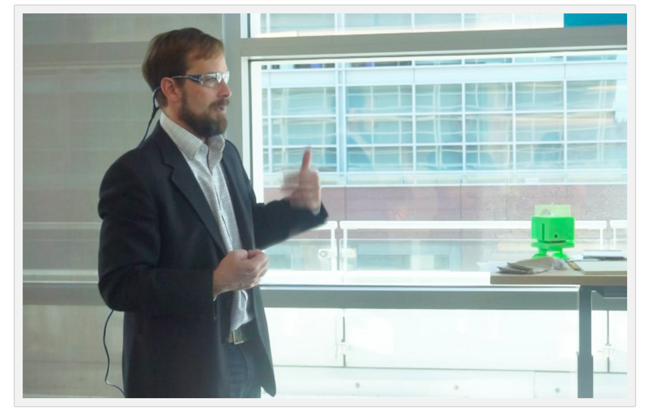  
5 Typical Value Clusters (WDC)**

1. Data Enrichment, Augmentation & Tagging (enriching & organizing unstructured data )  
2. Sensemaking, Interpretation, and Understanding (understanding unstructured data at scale)  
3. Interaction, Responses and Conversations (engaging and interacting with humans; AI / bots / augmentation)  
4. Translation (translating languages, intents, formats, ideas)  
5. Visual Recognition and Image Analysis (seeing & interpreting visual data)

As IBM CEO Ginni Rometty said "AI systems will revolve around augmenting human intelligence and AI won't replace humans anytime soon. Our technology, products, services, and policies will be designed to enhance and extend human capability, expertise, and potential. Our position is based not only on principle but also on science"

<https://youtu.be/OyM3GfHVY4w>

<https://youtu.be/80NUoh35v5o>

# Exploring Design Patterns – Enterprise AR/VR Solutions

# Exploring ideas around Design Patterns (meta-use cases) for Enterprise AR/VR

# 

# Decision Support

Help humans summon and engage data to help with decisions.   Consumer: high-value feature rich options (home decorating, automobile) helps buyers compare & understand (see) options.  ERP / Strategic:  Executives with data-on-demand, verbal command & control BI ERP integrations. Shared visualizations

# Cognitive Extenders

Help executives and innovators reduce cognitive load and extend cognitive range.  Better reasoning, recall, decision support, social navigation & connection making. Context aware information augmentation.  Instant context-aware data recall and visualization for decision support.  Collaboration catalyst.

# Cognitive Wingman

Jarvis, KITT, HAL.  Sensemaking systems understand context, to help. Use cases include autism, eldercare, Alzheimer’s & PTSD.  Cognitive Wingman is a human assistive AI/ADA buddy embedded inside AR headset – microphones & camera enable sensemaking & AR projection & audio to guide - or to guard

# Expertise Projection

Amplify and project scarce expertise.  Highly skilled medical specialists projecting expertise 2000 miles away to nurse practitioners who touch patients.   Industrial – leverage expert engineers at distance to help low skilled workers repair or deploy complex assets.  Hands free.  Information overlay.

# Knowledge Map & Recall

Dark Data / Data Exhaust. Enterprises are drowning in data.  Knowledge & expertise fuels continuing innovation and digital transformation. Workers retiring, taking key knowledge. AR enables knowledge capture & recall across time/space. Verbal command/control, visual delivery. Leverage spatial memory.

# Unified Communications

The final destination for UC?  As close to being present, without actually being present.  Project remote attendee into an empty seat at a board meeting 3000 miles away.  Re-watch 2 year old meetings.  Look into the eyes & face of job applicant. AR for UC3.0 enables human communications at distance

# Digital Twin / Industrial

Digital Twin is virtual/digital representation of a physical entity or system, living model that evolves over time, includes structured and unstructured data.  IOT and predictive analytics. AR allows a field worker to see and engage various data layers projected atop asset.  Oil & gas; aviation; high value assets.

# Neural Adaptive

(Speculative) NLU powered context gathering / sensemaking.  Emotion and eye tracking. Neural network & deep learning powered systems to recognize patterns from biometric signals (EEG/FMRI). Education optimization. AR content & agents serving as baseline reference for neural adaptive AR systems.

# Healthcare & Pharma

Research & Drug Discovery is a high-dimensional data space.  AR helps understand texture and shape of data;  fosters collaboration; and assists with visualization. Specialist doctors don’t scale well, AR helps scarce doctors project expertise to more places; and can help with teaching

# Infrastructure

AR enables engineers to see into, and project onto, complex and/or aging infrastructure assets to make best use of data, in field, real time.  Touches Digital Twin;  Decision Support;  Knowledge Mapping and recall, to enable AR equipped user  
to see best available data to leverage actionable intelligence

# Education

AR opens up new ways for children and adults to interact with, and consume and retain knowledge, in the most efficient and effective way – for each person.  Customization;  interactivity; flexibility and leverage spatial and visual components of AR for learners most benefiting from methods.

# Gaming & Fantasy

Escape & entertainment. Sophisticated VR allows users to make-believe.  Multiplayer, massive communities, realistic, exciting, and immersive.  Value drivers of modern cinema , plus player immersion inside plots – which will include adult entertainment.  Bend physics, time & space in a Holodeck

# "Thought Controlled" Electric Wheelchair

**FIRST TEST:  "Thought Controlled" Electric Wheelchair**

**I was curious if, in a day, I could hack together a system that could use brain electrical signals to control a vehicle...**

<https://youtu.be/MBkyToar2_4>

This is similar to what IBMer Josh Carr did to do a thought controlled BB8 droid <https://www.youtube.com/watch?v=K-4mp_e5v4A.>

Video below is first test.  System needs a little damping - and I think I may need to increase my midichlorians -  - but the basics are in place.

**First Test of the EEG Sensor Signals Controlling the Electric Wheelchair**

**My driving sucks, but i'm also on my third glass of wine...**

**Rough Schematic showing sequence of control**

1. think and control from human
2. Emotiv epoc receives signal
3. Emotiv system thresholds 'map' signals to keystrokes f b l r
4. Keystrokes sent to laptop (ouput  as keystroke)
5. Arduino serial monitor listening - receives keystrokes <https://github.com/rustyoldrake/arduino_random_bits/blob/master/telekinetic.ino>
6. Arduino drives LEDs and also pulls lines low in relay -
7. Coils induce magnetism for controls of electic wheelchair
8. Wheelchair moves

**Hand Wound Coils driven by arduino stimulate controls of electric wheelchair**

**Home Stretch:  Wearing EEG just after First Test**

**Harry Potter Sorting Hat 2.0 – Brain Gain**

This article describes an idea for expanding the Harry Potter Sorting Hat hack, from verbal signal input, to also include EEG brain signals, to assign Harry Potter house.

Some background - a couple of years ago I built a Harry Potter sorting hat powered by IBM Watson Speech to Text and Natural Language Classifier

<http://www.businessinsider.com/real-life-harry-potter-sorting-hat-uses-watson-2016-6>

instructions for a simple version here:

<https://dreamtolearn.com/ryan/r_journey_to_watson/49>

the ground truth for the NLC is here:

<https://github.com/rustyoldrake/Harry_Potter_Sorting_Hat_Simple>

And lately, I’ve been experimenting lately with EEG waves to move things and do things. Here, I’m driving around a hacked electric wheelchair

<https://dreamtolearn.com/ryan/cognitivewingman/5>

I was inspired by my colleague Josh Carr who did a similar thing with a BB8 droid

<https://developer.ibm.com/recipes/tutorials/control-spherobb8-by-voice-through-ibm-watson-iot-platform/>

**HYPOTHESIS:**

I believe that the Emotive EEG 14 channel headset can inject additional signal into the Harry Potter Sorting Hat prototype (voice + EEG) but can operate on EEG only to produce reliable and reproducible sorts.

**TEST:**

The test for this is repeatable, blind-test able hat interpretation of thought signals.

* Aggression, rage, anger (Slytherin)
* Pride, Joy, Nobility (Gryffindor)
* Cerebral, thoughtfulness, cognitive load like math problems (Ravenclaw)
* (for now I’m going to leave Hufflepuff out as a low intensity signal, or perhaps as default)
* To begin, just on 1 subject.

**DEVELOPING:**

Anyway, time permitting, I’m going to start building this in April 2017.. will see how it goes.

**Key Learnings:**

* Blunt force (non-EEG) signals, which I suspect are largely muscular, are available out of the box and need almost no training by user.   For example, for ‘four coordinate’ control  for forward, backward, left and right – you might use ‘clench’; ‘smile’; look/blink left and look/blink right
* EEG “thought driven” commands take a little bit of work, but they do work.  One of my colleagues imagined hitting a three point shot to win a basketball game.  That was a ‘go to’ memory that invoked both memory; positive emotion; and reliably lit up parts of his brain to move the needle
* Training and tuning, according to online posts, are essential for good performance, so it’s unclear how well ‘just putting the hat on’ will work across varying people and brains
* I’ve also been doing a little work in the “Autism” use case area – leveraging emotion and tone analysis for kids on the spectrum.  <https://dreamtolearn.com/ryan/cognitivewingman/3>  - so there’s a component from this work that may dovetail here
* COST / HACK? Emotiv gear is cool, and really opened the door to consumer grade EEG access, but it has a few drawbacks.  It’s expensive, nearly $1000 for the 14 channel hardware and $300 for the 5 channel ‘dry’;  to get to the useful stuff it’s a $50 monthly subscription;  I’ve seen reviews and heard from peers, and from my own experience, it’s delicate and breaks;.  I’m pleased I bought it, but for technical folks considering a purchase,  I’d consider doing some research into hacking / building your own low fidelity version.  I’ve seen a few ‘guitar pick’ youtube videos.   A DIY approach will also allow greater understanding of the signals, amplification, etc.
* FMRI (portable0 I think within 10 years, possibly 5, we’re going to see some very interesting developments in FMRI.  At CES this year, I saw a  booth that had a demo that was not much bigger than a motorcycle helmet

**A Billion Dollar Thought Experiment: National Cognitive Wingman**

The US Economy’s GDP according to Wikipedia is $18 trillion – that’s trillion with a “T” – thousands of billions.  Massive.

Now let’s imagine if we could create a machine, accessible to the numerous stewards of the US Economy, that would be SYNOPTIC and HOLISTIC – providing a solution to help them make better decisions, manage risk, collaborate with each other – and generally be better stewards.

We consider:

1. COST BENEFIT – the system would not be cheap to build and operate.  But it would also offer, if it worked, sizable benefits.
   1. COST: On the cost side, let’s imagine a cheap insurance policy – say a fraction (1%) of 1/100 of one year’s GDP, over a decade.  1% of 1% is 0.0001.    **To put that in perspective, if you owned a $1m home, and applied the same ratio, that’s $100 insurance policy that covers 10 years.** For the US Economy, a similar ‘insurance policy’ would be $1.8 billion.  As a benchmark, the F-35 program is $300b+
   2. BENEFIT:  This is hard to price, but we can ask – what is the value of, over a dozen key decisions each year, of eliminating one mistake, or better managing risk.   Housing bubbles; S&L; Derivatives WMDs; Long term economic stagnation; regional dangers, etc..

Necessary Features

**So might we build/buy for nearly $2b?**

1. **UX ACCESSIBLE - Natural Language / Human Interface (Verbal and Visual) - speak/converse and see to allow normal humans to use it**
2. **DATA SYNOPTIC - Plugged into nearly everything**
3. **HOLISTIC - Interconnected - and aware of nuance of relationships**
4. **SMART - Can answer the hard questions (mathy/predictive, or knowledge retrieval)**
5. **EVOLVING & LEARNING - understanding shortfalls, and closing gaps.**
6. **SAFE & ETHICAL - of course**
7. **PROACTIVE and/or RESPONSIVE -  alerting when bad things are happening that users likely to care about.**

**Developing....**

### The Method of Loci - Using Cognitive Extenders to Enable and Capture

As mentioned in one of the opportunity classes in my February blog here: <https://dreamtolearn.com/ryan/cognitivewingman/3> - Cognitive Extenders can include use of the Method of Loci.

Per Wikipedia "The **method of loci** (*loci* being Latin for "places") is a method of memory enhancement which uses visualizations with the use of spatial memory, familiar information about one's environment, to quickly and efficiently recall information. The method of loci is also known as the **memory journey**, **memory palace**, or **mind palace technique**. "

<https://en.wikipedia.org/wiki/Method_of_loci>

Augmented and Virtual Reality systems, equipped with Natural Language Understanding, can likely offer ways to translate ideas and thoughts to the AR/VR space.  This will be helpful for collaboration, therapy, and memory aids - and potentially applicable to dementia, PTSD, or professionals seeking a cognitive extender..

More to come, but having walked around the augmented world expo last Friday - it seems the technology pieces exist today to compose such a system.

# Neuralink and the Brain’s Magical Future - by Tim Urban

## <http://waitbutwhy.com/2017/04/neuralink.html>

Superb "Big PIcture" look at some industry leaders and big thinkers...

(Love his Unpretentious writing style, and humble-art)

**Composing Cognitive Agents - Patterns**

Since I posted on Cognitive Wingman in December, I’ve been doing some thinking about how to compose effective cognitive agents, and where to start from a pattern and architecture perspective.  This is for systems going beyond rifle shot use cases – and mimicking emotional intelligence.

The simple image below distills much of it down.  The key ingredients necessary for it all to come together and have a useful, engaging, and believable avatar (or if you prefer, cognitive enabled agent)

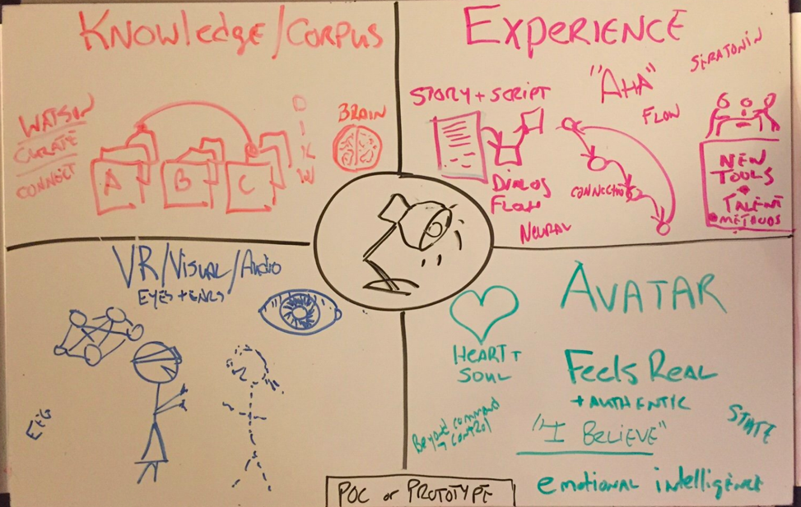

1. KNOWLEDGE /CORPUS (Brains) – **Knowledge**.  This is actually the easy part.  Creating a system that can tap public internet knowledge, aggregate, curate and disseminate data, information, knowledge and wisdom (DIKW).     The Avatar needs to know stuff – so this knowledge needs to be available.

1. VR / VISUAL  / AUDIO (Eyes and Ears) – **Sensory**.  In this case I’m assuming a headset worn to deliver AR or VR photons into eyeballs – but could be a flat screen or an immersive room.  But the avatar needs to be seen and heard (and to also see and hear);   A beautifully rendered AV Piece is essential, but also requires the other ingredients.

1. DIALOG & CONTEXT (Story & Script) – **Experience**.  whether it’s a 10 second interaction to discuss a shopping list, or a multi-decade relationship – there is a story arc to the relationship.  Dialog.  Scripts,  Flow, are needed.  Done well, they will produce what seems to be emotional intelligence – and moments of “Aha” (serotonin shots)

1. AVATAR (Heart and Soul) – **Authenticity**.  Relationship.  Empathy.  When the other ingredients are composed - this where the magic happens – when the eggs, flour and sugar become a wedding cake.   It’s where the user feels there is an “other” being interacted with.  An “I believe” moment sufficient to overcome periodic trespasses and errors of logic. System that can remember, hold state, know context and react with a reasonable level of emotional intelligence.

The design pattern (macro) is still developing – and will probably be part of a much more complex architecture for Embodied Cognition

**Further Reading**

<https://en.wikipedia.org/wiki/Embodied_cognition>

<https://en.wikipedia.org/wiki/Theory_of_mind>

<https://en.wikipedia.org/wiki/Marvin_Minsky>

<https://en.wikipedia.org/wiki/Society_of_Mind>

https://dreamtolearn.com/ryan/cognitivewingman/11

For a few months, I’ve been thinking about Cognitive Enhancement, Cognitive Extenders and Neural Prosthetics.

The broad theme of how technology can augment human abilities - and amply human potential. A few other blogs here.

But before we dig in, a bit of background on the terminology…

Neural Prosthetics: Neural prostheses are mechanisms that can substitute a motor, sensory or cognitive modality that has been damaged or underdeveloped. E.g. with a brain injury, dementia or autism.

https://en.wikipedia.org/wiki/Neuroprosthetics

Or put another way, computers, chips and code connected to human brains, to help people live better.

Although neurocognitive prostheses are not yet in wide use, it’s a reasonable bet that implantable neurocognitive brain-computer interfaces will begin to emerge more widely over the next decade – especially given the work already underway: http://waitbutwhy.com/2017/04/neuralink.html and taking into account the caliber of people with the ‘can do’ attitude that figured out how to do this with a rocket.

But today, my focus is less on Neural Prosthetics for brain injury, and more about Improving memories and recall; building idea frameworks, and sharing Mental Models - Cognitive Enhancement with Cognitive Extenders

This also has the added benefit that there is no need to put holes (or wires) into my head. We use some less invasive (and old-school) experimentation, along with a little imagination.

Method of Loci / Mind Palace: The METHOD OF LOCI is also known as the memory journey or memory palace technique. The method is a mnemonic device adopted in ancient Roman and Greek rhetorical treatises.

Wikipedia has a nice summary: https://en.wikipedia.org/wiki/Method_of_loci

Fast forward 2500 years, to the modern Sherlock Holmes TV series, the term Mind Palace is used. This Smithsonian Magazine article provides a nice overview:

“To use the technique, visualize a complex place in which you could physically store a set of memories. That place is often a building such as a house, but it can also be something like a road with multiple addresses. In the house version, every room is home to a specific item you want to remember. To take advantage of the mind’s ability to hold onto visual memories, it often helps to embellish the item being stored—the milk you need to buy at the grocery store might become a vat of milk with a talking cow swimming in it. When those memories need to be recalled, you can walk through the building in your mind, seeing and remembering each item.”

Anyway – I thought I’d give it a whirl - so for the last few weeks, I’ve been building a mind palace with my daughter Julia. Each night at bedtime, after story time, we close our eyes and go to our “Mind Palace” – or rather, return to it. We review, remember and reinforce, and keep building...

She’s very good at it. The kids have been building quite a bit with Minecraft lately (which is a terrific tool) – and I suspect the spatial and visual practice is helpful to her mind palace construction.

Today I spent a couple of minutes to build a model of what I thought our mind palace looked like. The image below is missing a bunch of pieces, like the rainbow-tire-path (sorry Julia!) but when I showed it to her, she immediately recognized it – even though we had just imagined it in our minds, independently.

For me, it was a powerful moment– as the mental model of our ‘mind palace’ now exists in three places – in her mind; in my mind; and now in VR in the cloud.

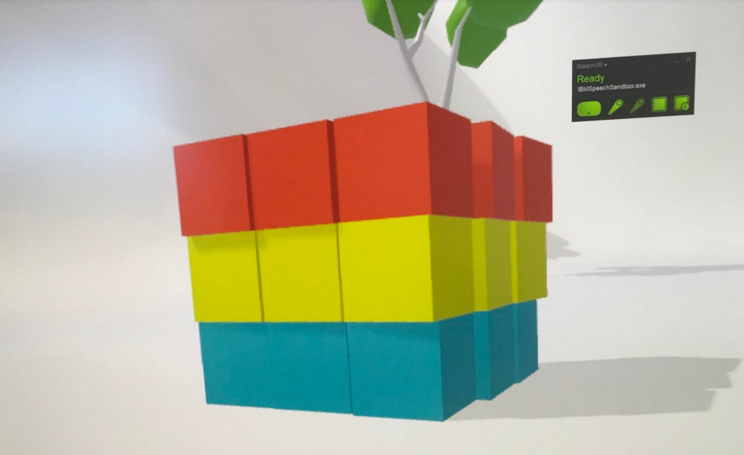

The image above was created in VR on an HTC Vive. The program I used is called Speech Sandbox (IBM Watson Speech and Natural Language Understanding + Unity toolkit) which allows VERBAL COMMAND AND CONTROL inside VR. It's pretty fun - If you want to stack 10 red sports cars then blow them with rocket launcher, while gorillas and dinosaurs cheer you on – just say the word! Magic. ( Tilt Brush is good too)

Why I am Excited about Mind Palaces / Cognitive Extenders:

Johannes Gutenberg's printing press changed the world by allowing for the encapsulation, movement, dissemination of, and access to - IDEAS.

This technology shares many of the same traits - it...

• Can represent ideas in human imagination and also VR space

• Is Shareable between 2 or 2000 people - and is scale-able.

• Is Spatial (additional dimension for my aging brain to hold on to ideas/memories)

• Is Persistent (when you come back a week later) and 'summon-able'

While it's probably a stretch to suggest influence on par with the printing press (or a great book) it is a new and potentially powerful knowledge vector - and perhaps, we are seeing the beginning of a new period of innovation in brain computer interfaces and cognitive extenders - made possible by a convergence of several powerful technology components.

Image Sources:

• https://i.ytimg.com/vi/YdfUaydquXs/maxresdefault.jpg

• http://www.smithsonianmag.com

• https://www.pinterest.com/explore/minecraft-houses/

• Sherlock Holmes TV Series - BBC

These opinions are my own, and not of my employer. I’m a technology enthusiast but am not a subject matter expert in neuroscience.

**PID, AIGo, SuperAIGo**

By 2050, if even half of the technological breakthroughs happen in Brain Computer Interface that are being explored today, what might a highly integrated human-BCI-AIBot look like?  And how will people describe the intersections between human consciousness-knowledge-ideas and the same ideas at or across a Fuzzy Edge?

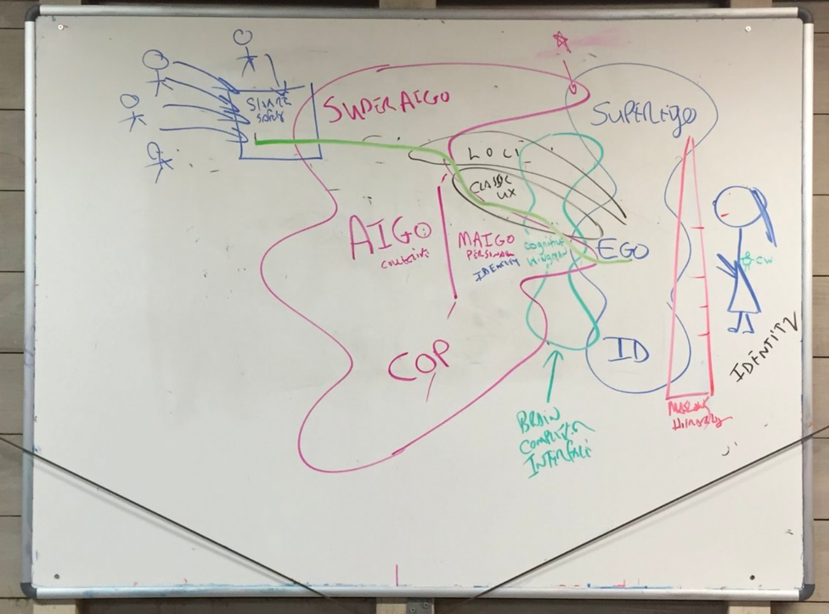

Whether it's from the more invasive [neural-lace](http://www.techworld.com/data/what-is-neural-lace-3657074/) , or the less invasive [fNIRS](https://en.wikipedia.org/wiki/Functional_near-infrared_spectroscopy) (functional near infrared spectroscopy) - it seems quite likely within a few decades we're going to continue to get more integrated.

This interconnection got me thinking - how might we describe the interface & hierarchy of AI that mirrors the human one, in a language that will resonate? What ego-stack might make a Cognitive Wingman tick?  And most importantly - can we make it sound sort of cool and catchy?

**ID EGO SUPEREGO**

About a hundred years ago, Freud 1920 presented the idea of [ID EGO and SUPEREGO](https://en.wikipedia.org/wiki/Id,_ego_and_super-ego) in an essay titled: Beyond the Pleasure Principle.  <https://en.wikipedia.org/wiki/Id>,_ego_and_super-ego

"According to this Freudian model of the psyche, the id is the set of uncoordinated instinctual trends; the super-ego plays the critical and moralizing role; and the ego is the organized, realistic part that mediates between the desires of the id and the super-ego."

As with humans - the stack of AI has a hierarchy of needs - and concerns ranging from the terrestrial to the celestial....

What might this look like?

**PID AIGo SuperAIGo**

I originally had the lower level instinctual pieces (reptilian, base of brain) tagged as COP - Computer Operating Properly (COP Watchdogs in the old days) but PID ( <https://en.wikipedia.org/wiki/Process_identifier> ) has a better ring.

The intersections are interesting.

* Can people have shared AIGo? (ego) and are there hyper-personal my-AiGos? (MAIGos ?)
* If a person, group or AI avatar were to create a 'mind palace' and represent ideas (mental models) - where would they live?  And how would they be represented to different users?
* What role might ethics, compliance and regulation play in SuperAIGo?  How about access?

**13. Random Thoughts: Non-linear Storytelling and Non-Deterministic Experiences (Brain Dump Warning)**

I watched Cloud Atlas a few nights ago, and have been chatting with my friend over the last few months about his experience with Prolog (first used in 1972); Prolog is a general purpose logic programming language associated with artificial intelligence and computational linguistics. https://en.wikipedia.org/wiki/Prolog ; I’ve also been doing a lot of thinking about how to create Emotionally Intelligent bots / avatars that don't suck. Good personalities, but also good experiences, which involves a level of capability on storytelling or experience.

Netflix also recently released Interactive Storytelling...

https://www.forbes.com/sites/anthonykarcz/2017/06/20/never-bored-netflix-launches-interactive-storytelling-to-save-summer/

Backing up, let’s chat a bit on jargon, with examples:

Nonlinear narratives:

Nonlinear narratives have been used for some time in cinema – as Wikipedia puts it “where events are portrayed, for example, out of chronological order or in other ways where the narrative does not follow the direct causality pattern of the events featured, such as parallel distinctive plot lines, dream immersions or narrating another story inside the main plot-line. It is often used to mimic the structure and recall of human memory, but has been applied for other reasons as well” https://en.wikipedia.org/wiki/Nonlinear_narrative

https://www.finaldraft.com/learn/final-draft-blog/what-is-nonlinear-storytelling/

Joseph Heller's Catch-22 (1961) and Kurt Vonnegut's Slaughterhouse-Five (1969) are two classics. (The latter I recommend both the book and movie); The Movies Cloud Atlas, Reservoir Dogs, and Memento are others.

Non-deterministic experiences:

Non-deterministic stories and experiences can have many outcomes, depending on the user and their choices. There are many in wide use – for example, in Massively multiplayer online role-playing games (MMORPGs) – which are a combination of role-playing video games and massively multiplayer online games in which a very large number of players interact with one another within a virtual world. https://en.wikipedia.org/wiki/Massively_multiplayer_online_role-playing_game

Old school, there are the Choose Your Own Adventure books – a “series of children's gamebooks where each story is written from a second-person point of view, with the reader assuming the role of the protagonist and making choices that determine the main character's actions and the plot's outcome.”

https://en.wikipedia.org/wiki/Choose_Your_Own_Adventure

Up and to the right:

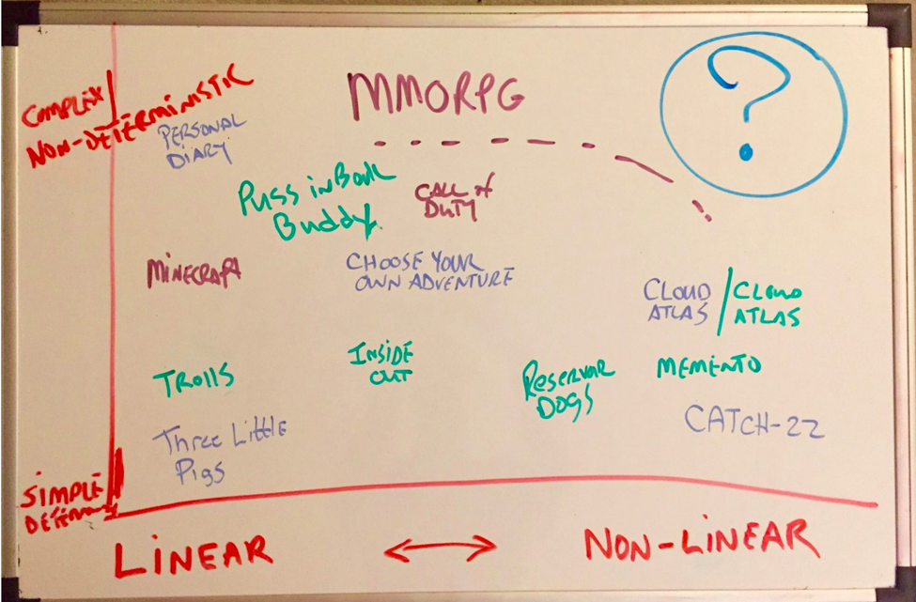

So what might a highly non-linear and highly complex, non-deterministic (personalized and flexible) user experience look like? I dont think it's well defined yet, but a good place to start sharpening our mental model, is by filling in what we know from existing books, movies and video games...

For me, an even more interesting question is...

Who is going to build / architect all of this? Lookahead?

What is the new generation of artists, technologists and/or weavers that will pull this all together?

It's a new creative process, and much like the Choose Your Own Adventure Authors needed to create threads, and Cloud Atlas producers needed complex devices to track and understand;

Human understanding,

empathetic systems,

dynamic content generation driven by some form of rules

sanity checking the dynamic outcomes through the lens of human experience

retrospective updating of rules, algorithms and reality based on future/downstream choices

other content creation within a broader, more flexible rules set -

We may see new kinds of companies emerge - a blend of conversation bot companies like https://www.pullstring.com/ mixed with scriptwriting, psychologists leveraging computer gaming best practices...

New media vectors, new skills, new ways of thinking...

New tools are needed. New skills are needed. If highly personalized Augmented Reality exists in 2050 - I suspect a substantial portion of the content will be immersive. . "Up and to the Right"

Still chewing on some ideas here... will update as thinking evolves...

Bonus: Kurt Vonnegut Lecture on the Shape of Stories (39 minute mark)

<https://www.youtube.com/watch?v=4_RUgnC1lm8>

# 14. The Davos Dashboard: Crafting a Thought Experiment - Part 1

Lofty Goals from the Mountaintop

Every year, the World Economic Forum (WEF) hosts a meeting of global political and business leaders at a very posh ski resort in Switzerland.

Davos

The World Economic Forum is a nonprofit foundation with the mission of "improving the state of the world by engaging business, political, academic, and other leaders of society to shape global, regional, and industry agendas"

In the crisp mountain air, lofty goals are discussed by the nearly 3000 men and women that make up this group of global elites. Their ranks include heads of state, CEOs, academics, financiers, non-profits, scientists, and other big thinkers. The typical attendee is well educated, industrious, global-minded, and well-connected.

But the “Davos Man” has his skeptics – like Samuel Huntington, a US academic and political advisor (himself a member of the group); and Steve Bannon, who lamented that “the middle class, the working men. . . are just tired of being dictated to by what we call the party of Davos”. There is a full spectrum of Davos skeptics, some wary of conspiracy, while others are simply uncomfortable with an “elitist” organization that seems to epitomize wealth gaps and rising Gini coefficients.

However, for this thought experiment I will play the role of an optimistic Canadian. I will assume that most members of the Davos collective are a force-for-good with altruistic intentions. Powerful people trying to “do good while doing well”, and in general, using their positions of influence to be good stewards of the planet. The Davos participants I’ve had the opportunity to know are good people who have worked hard for their successes. Many are parents and grandparents, who like the rest of us, hope to leave the world in decent shape for the generations to come.

Which brings us to our thought experiment….

HOW MIGHT WE COMPOSE EMERGING TECHNOLOGIES TO HELP THE DAVOS ELITES, IN THEIR PURSUIT OF THE NOBLE MISSION?

By emerging technologies I mean the full alphabet soup of AI (Artificial Intelligence, Augmented Intelligence); ML (Machine Learning); DL (Deep Learning); AR (Augmented Reality); UI/UX(User Interface /Experience novel methods); BCI (Brain Computer Interface); and Cognitive Extenders.

To leverage technology to help global leaders access knowledge and wisdom, in order to make better decisions and be better stewards. To leverage a rapidly expanding, increasingly heterogeneous data universe, and knowledge base, to “improve the state of the world.. and shape global, regional, and industry agendas"

A technical tar ball with some awesome sauce.

So where do we start?

Step 1 - Exploring the Current Tools

To understand best-fit future tools, we first explore the current WEF toolkit, including:

Public Domain Information – This is information available to the general public – e.g. Newspapers, Magazines (e.g. Economist, Foreign Affairs), Social Media, Traditional Media (CSPAN, CNN, BBC), and other organizations (OECD, UN).

WEF Reports – such as “Inclusive Growth and Development Report 2017” (focused on socially inclusive economic growth); “Global Risks Report 2017” (highlighting the most significant long-term global risks); and “The New Plastics Economy” on plastics life cycle. The reports are nutrient rich, but are static snapshots and information silos.

Libraries – like the Digital Transformation Initiative Library: the initiative offers insights into the impact of digital technologies over the next decade. Its purpose is to support public-private collaboration that unlocks value for both industry and society.

Frameworks / White Papers – Mental models and frameworks to shape conversations. For example, “Encouraging Futureproofing” provides “A Conceptual Framework for Measuring Country Performance” – in this case, a framework to motivate decision-makers to engage in long-term thinking by enabling them to benchmark their societies’ preparations for the future.

Forums & Networks – Human connections. Forums like Davos help people connect to share and test ideas (cross pollination). Participants do networking & relationship building; explore new issues, and build trust. Many connections persist after the events.

So reflecting on the tools above and the Davos mission of "improving the state of the world by engaging business, political, academic, and other leaders of society to shape global, regional, and industry agendas"

We’ll want to baseline our toolkit with the following attributes:

Data Distillation – to digest and distil out the massive wall of global data

Data Discovery – a tool for the navigation of data, knowledge & ideas

Connection Making – to create Eureka moments from idea intersections

Network Building (people) – to connect thinkers/doers for shared ideas

Perspective Enhancing – to expand and constructively challenge thinking

Decision Support – to provide robust and reliable information for decisions

Action Supporting – to help execution with KPIs/monitoring. Enablement

User Interface – built so it actually gets used. Repeatedly. By all users.

Unsurprisingly, there's quite a bit of overlap with the meta-use cases we're seeing for Enterprise:

https://dreamtolearn.com/ryan/r_journey_to_watson/57 and https://dreamtolearn.com/ryan/cognitivewingman/4

Step 2 – Understand The User

User Experience and User Interface will be essential.

The Davos attendees are a large and very diverse group with a wide range of skills. Indeed, the diversity is a fundamental strength of the group – with diverse perspectives and experiences. Perfect for idea cross pollination and vigorous debate.

Some participants are old-school technophobes. Others are among the most technically sophisticated on the planet – on the bleeding edge and already writing the next chapters in technology.

The solution needs to work for everyone, so will require

Personalization – a system that can ‘gauge’ the user and automatically adjust and adapt.

Learning – a system that can learn and adjust both through observing actions, but also from explicit commands. Both granular and aggregate.

Evolving – the system will not be perfect at launch, so needs a feedback mechanism for evolution and improvement.

Flexible – the system will need to be very flexible – which will likely translate into a modular, componentized architecture.

Cognitive – a system designed to optimally communicate with humans should present knowledge that is consumable in the ways people think, explore and communicate. Natural language (spoken word), imagery, metaphors.

Step 3 – Gap Analysis

Knowing the mission, the current state of tools and the diverse set of users, we can now perform an initial Gap Analysis.

There’s no technical magic here. Just some good old fashioned interviews with people – talking with a representative sample of the users to understand What’s working well? What’s not?

Gaps may include a few of the following:

Buried insights: WEF Libraries, Reports, Models are nutrient-rich, but not easily accessible to busy leaders with other priorities the other 51 weeks of year

Missed Opportunities: Failing to connect with the right people in the group –people outside immediate network can be the best ones to expand thinking

Continuity and Momentum: Electricity and ideas may fill the air atop the mountain, but momentum can fizzle with time and distance.

Information Overload: With an abundance of knowledge and information, and only 24 hours in the day, current methods of curation and knowledge delivery are not ideal

Etc…

Step 4 – Strong Foundation: Trust and Security

Any system being considered that touches so many people in influential positions will be a tantalizing target for “bad actors”. Individuals who may be profit motivated; Nation-States with geo-political agendas; and potentially some among the number who may not be 100% altruistic.

Doing good does not mean being naïve.

The system must, at its core, be Trusted, Secure and Discrete

TRUSTED – The users must trust the system’s source data, algorithms, and usage confidentiality; Faith in architects and architectures.

Reputation and Personal Brand

Company or Country reputation and regulations

Street smart – designed, built, operated and monitored in a manner that acknowledges the existence of bad actors with

The role of Blockchain

Step 5 – Begin Innovation and Be Agile

Davos Dashboard: Brainstorming on the Bus

Dashboard Panel Candidates

CONFIDENCE – consumer confidence, VIX

GDP – productivity globally, by nation, by subgroup

TRADE – internationalism, bilateral agreements, cargo rates

MONEY SUPPLY & INTEREST RATES – financial foundations, bond rates,

EMPLOYMENT – levels and quality of employment, flexibility of labor

FAITH – fiat currency robustness, optimism, corruption index

STABILITY & SUSTAINABILITY- wealth distribution, power structures, judiciary

GOVERNANCE & TRANSPARENCY – transparency, accounting boards, audit

INDUSTRY – industrial strength, diversity, energy blend

EDUCATION – vocational training, 2 year programs, PTeck, tertiary

INVESTMENT – inflows and outflows, risk premiums, VC markets,

FOOD & AGRICULTURE – domestic production, exports, ag science

WATER – availability, cleanliness, monitoring, irrigation, water tables, oceans

INNOVATION – technological and disruption, basic research funding

HEALTH & WELFARE – OECD, UN Development Index

DISEASE & MORTALITY – infant mortality, tropical diseases, malaria

CLIMATE – global, long term, warming oceans, CO2, pollution

WEATHER – crops and weather, commodities, hurricanes,

DATA & PRIVACY – personal security, identity theft, data protections,

HUMAN RIGHTS & SAFETY – human trafficking

GLOBAL & NATIONAL SECURITY – nuclear non proliferation

ETC...

Cognitive Wingmen: Digital Humans

We are currently passing through the era of Siri, Cortana and Alexa - and evolving to the next generation of Cognitive/AI powered assistants. These more advanced assistants will serve their human companions to help them navigate all aspects of personal and professional life.

The Cognitive Wingman is a more sophisticated, emotionally intelligent and socially aware, highly personalized cognitive assistant to help the Davos attendee.

The Digital Humans can act as Cognitive Extenders

Decision Support: Help humans summon and engage data to help with decisions. Consumer: high-value feature rich options (home decorating, automobile) helps buyers compare & understand (see) options. ERP / Strategic: Executives with data-on-demand, verbal command & control BI ERP integrations. Shared visualizations

Cognitive Extenders: Help executives and innovators reduce cognitive load and extend cognitive range. Better reasoning, recall, decision support, social navigation & connection making. Context aware information augmentation. Instant context-aware data recall and visualization for decision support. Collaboration catalyst.

Cognitive Wingman: Jarvis, KITT, HAL. Sensemaking systems understand context, to help. Use cases include autism, eldercare, Alzheimer’s & PTSD. Cognitive Wingman is a human assistive AI/ADA buddy embedded inside AR headset – microphones & camera enable sensemaking & AR projection & audio to guide - or to guard

Knowledge Map & Recall: Dark Data and Data Exhaust. People and Organizations are drowning in data. Knowledge & expertise fuels continuing innovation and digital transformation. AR enables knowledge capture & recall across time/space. Verbal command/control, visual delivery. Leveraging spatial memory.

Summary: Crafting the Thought Experiments

BLUE SKY: If given a $100m budget to build a "Davos Dashboard" using the most advanced AI/Cognitive/ML/Deep Learning technologies, what would you architect? How would you approach your 'sprints'?

USE CASES: Exactly what are the use cases? What is a storyboard for a solution that would be relevant to at least 2/3 of WEF attendees? Why would they want to use it? What's the unmet need?

AUTOMATION: To what extent would the final deliverable, or intermediate validation (sprint) use a HUMAN "man in the middle" - e.g. how/why would any system be better than having one of the worlds best networked Polymath as a personal assistant?

SUCCESS METRICS: What is a win? Success Criteria & Key Performance Indicators (KPIs): KPIs - As we explore mission, and success – we require success metrics – similar to KPI’s at a Fortune 500 company. If successful in 5 or 50 years, what yardsticks can we use to measure success?

ACTIONABLE INSIGHTS: What are some examples of them? What are 10 plausible scenarios where the solution could enable a new perspective; connections and ultimately actionable insights to serve the mission? Which one is most impactful - or most realistic near term?

LENSES & BENCHMARKS – Compare and contrast populations, countries, economies, sectors, knowledge. What are the yardsticks and how can the similarities and differences (and distances) be represented visually – or conveyed as ideas?

NATIONAL STEWARDSHIP: If an OECD Prime Minister wants to know how their departments are doing today, and 3 weeks/months/years from now – and relative to others, how might this happen? How could semi-sensitive data be accessed and safely shared with controls?

ASTRAL NETWORKING: What might a Davos Digital Human look like, flying above all in the “Astral plane”? Could Digital Proxies find each other, establish a relationship, and perhaps encourage their masters to engage with each other, where they otherwise might not?

WHITE HAT / RED TEAMS: How can we design robust systems to withstand attacks from bad actors? Should White Hats be used for penetration testing? Red team simulations?

HOPE FOR BEST, PLAN FOR WORST: How to design for fault tolerance? An Alternet with fundamentally different low level communications protocols (incompatible)? Should there be a kill switch?

INFORMATION QUALITY & ASYMMETRY: How can we measure Information Asymmetry? Score mental models? Grade data quality and assumptions? How can this be communicated to users?

In closing, there are a number of emerging technologies that can be combined to help world leaders access knowledge, wisdom, and each other - in order to make better decisions and be better stewards of the planet - to “improve the state of the world.. and shape global, regional, and industry agendas"

By identifying the current state, performing a gap analysis, and then using an Agile approach to test hypotheses - technologists can explore how to best support the mission.

Key questions include how to personalize; and understanding why and how a more automated and speculative technology solution, is better than current state. Cost / benefit.

# 15. Emotion is Energy

We humans are social creatures and we radiate emotion.    Literally.

We consider our **delightful** children with **beaming** personalities who have a **positive** influence on each other.  **Bright** students with **brilliant** ideas and **magnetic** personality.

We know that bold ideas can be shocking.  Laughter is infectious, and that a few choice words of anger and hatred can chill the atmosphere in a room – or ignite a national conversation.

The etymology of emotion comes from emovere: to move out and agitate.

As our human tribe continues to grow (nearly 10 billion people by 2050) we are increasingly connected to each other through social media and technology.

**We are a rapidly growing and more emotionally connected species.** And this matters.

It matters because the words carry meaning and emotion that can change how people behave, how they perceive, what they believe, and how they act.  It matters because the ideas and emotional energy can now happen at breathtaking speeds, extending across the world.   Emotion can move people to make legislative change; ignite revolutions; sway elections; promote violence and punish corporations.  Emotion motivates and agitates.

So who should care?   Probably everyone, but especially those charged with the stewardship of organizations or nations where this “emotional radiation” can have an impact

* CEO and Board of a Fortune 500 Company – Public Sentiment / Brand Optics
* The Homeland Security, Police, and Law Enforcement Agencies - Terrorism
* Securities and Exchange Commission (SEC) – Market Manipulation
* Internet Providers & Social Media Companies – The Message Vectors
* American Civil Liberties Union (ACLU) – The Free Speech Defenders
* Federal Election Commission (FEC) – Voter Fraud
* US Federal Reserve - Consumer Confidence Index (CCI)
* US Department of Defense / CIA – Foreign Political and Social Stability

On the final point, the US DOD publishes a Quadrennial Defense Review (QDR) that analyzes strategic objectives and potential military threats.  The 2014 QDR includes mixed messages. Optimistically it states “…unprecedented levels of global connectedness provide common incentives for international cooperation and shared norms of behavior” – but more darkly “...the effects are threat multipliers that will aggravate stressors abroad such as poverty, environmental degradation, political instability, and social tensions – conditions that can enable terrorist activity and other forms of violence.”  A mixed bag.

Stewardship requires situational awareness.  So where do we start?

**Situational Awareness**

By 2020 our accumulated digital universe of data will grow to 44 trillion gigabytes.  A majority of this data is unstructured – including data like tweets, news articles, call center transcripts, Instagram photos, resumes and conference room audio.

Technology systems will be composed to provide Situational Awareness.  This means tools to “crack the carbon” of the unstructured data.  To pull the emotional signal from the data.

Automation can help - but new ways of architecting the data, composing the systems, and synthesizing the knowledge, will be required.

**Many Missions: Toolkit Required**

Each mission is different.   The Fortune 500 CEO may be focused on Brand Optics and Public Sentiment.   The INFOSEC professional working for DOD or CIA may be focused on aggregation of intercepts or public social media trends.   Social media companies like Facebook and Twitter will have increasing duties to society to find a balance between free speech and threat reduction.

All will need mechanisms for signal extraction, and interpretation of the data.

As the intensity and reach of the emotional radiation grow – the tools to measure and manage must evolve with it.

**Sources**

1. <https://www.defense.gov/News/Special-Reports/QDR/>
2. <https://www.defense.gov/Portals/1/features/defenseReviews/QDR/2014_Quadrennial_Defense_Review.pdf>
3. <https://www.dni.gov/files/documents/Newsroom/Testimonies/SSCI%20Unclassified%20SFR%20-%20Final.pdf>
4. <https://en.wikipedia.org/wiki/Consumer_confidence_index>
5. <https://www.forbes.com/sites/bernardmarr/2015/09/30/big-data-20-mind-boggling-facts-everyone-must-read/#76e4956f17b1>

*This is my own opinion and the views may or may not reflect those of my employer.*

# 16. KNA - Knowledge Nexus Arrays

Encoding Ideas: Go Long with KNA

There are many different ways that we might ENCODE IDEAS and knowledge - in particular, complex ideas. Words, images, knowledge graphs, etc..

But been thinking lately about taking high-dimensional information and knowledge, and lowering the dimensionality of it. REALLY lowering it - i.e. down to a 1 dimensional string.

So what if we look to our own DNA for inspiration?

DNA encodes an enormous amount of information, and (arguably) "embedded knowledge" for how our biological selves can best survive. The DNA structure allows the 3 billion base pairs in each cell to fit into a space just 6 microns across.

If you stretched the DNA in one cell all the way out it's quite long. To find the length for a human - and uncoiled diploid human DNA with the two strands placed end-to-end can be calculated by multiplying the helix pitch/turn of B-DNA (34 angstroms) and the number of base-pairs in the DNA (6 billion) - the answer: about 2 meters long

So EACH one of my cells contains strands taller than me...

All the DNA in all your cells put together would be about twice the diameter of the Solar System.

KNA - Knowledge Nexus Arrays

Universal

Objective (consensus)

Portable / Shareable

Efficient

Questions to explore:

Four bases are found in DNA: adenine (A), cytosine (C), guanine (G) and thymine (T) . Is there a role for non-binary flags in the KNA? (probably not) - but if so, and more than 1 or 0 - How many states? 4? More?

White Space and Compression - probably 99.999% of the KNA string will be EMPTY. Can the standard compression algorithms work well on them? (Probably yes)

For idea intersections / VENN - (e.g. three ideas like the concept of SYSTEMIC RISK; (concept); back in the 1980's (time) during the S&L Crisis) - at what point do we create a new KNA strand? How much is too much idea to pack into one?

How might we organize the ideas on the KNA strand? (clustering, e.g. a temporal time-y area) Should we take inspiration from Library Science? Would they be sortable? (probably not)

Next Up

Still some noodling to do on this. More to come...

Other Links

"How DNA could store all the world’s data" Modern archiving technology cannot keep up with the growing tsunami of bits. But nature may hold an answer to that problem already. <https://www.nature.com/news/how-dna-could-store-all-the-world-s-data-1.20496>

# 17. The Fourth Industrial Revolution

Some nice brain stretching perspectives on the Fourth Industrial Revolution - on how we humans connect and engage with each other:

"The possibilities of billions of people connected by mobile devices, with unprecedented processing power, storage capacity, and access to knowledge, are unlimited. And these possibilities will be multiplied by emerging technology breakthroughs in fields such as artificial intelligence, robotics, the Internet of Things, autonomous vehicles, 3-D printing, nanotechnology, biotechnology, materials science, energy storage, and quantum computing."

<https://www.weforum.org/agenda/2016/01/the-fourth-industrial-revolution-what-it-means-and-how-to-respond/>

<https://youtu.be/khjY5LWF3tg>

WEF: "Ubiquitous, mobile supercomputing. Artificially-intelligent robots. Self-driving cars. Neuro-technological brain enhancements. Genetic editing. The evidence of dramatic change is all around us and it’s happening at exponential speed. Previous industrial revolutions liberated humankind from animal power, made mass production possible and brought digital capabilities to billions of people. This Fourth Industrial Revolution is, however, fundamentally different. It is characterized by a range of new technologies that are fusing the physical, digital and biological worlds, impacting all disciplines, economies and industries, and even challenging ideas about what it means to be human."

**18. Character Cartridges - Embodied Identity**

We are entering a fascinating convergence phase in media and technology. The next decade will see more conversations and POCs around how to develop character and identity for sensemaking systems, possibly leveraging AI.

Multiple technologies – including in mobile, AR, and deep learning - are rapidly converging to enable organizations to compose AI-powered systems only dreamt of in Sci-Fi novels and Hollywood movies.

These sensemaking (and empathetic) systems will quickly enable assistants who can play roles that include a “Cognitive Wingman” – similar to the automated intelligence seen in media: JARVIS (Iron Man); KITT (Knight Rider); HAL (Space Odyssey); Samantha (Her); TARS (Interstellar).

These systems will:

· Talk and listen

· Have identity

· Have relationships

· Are situationally aware

· Reason, Understand and Learn

· Understand context and remember things

· Can hold state for multiple ‘conversation turns’

· Behave in a manner that simulates emotional intelligence

With readily available technology - can build alpha versions of these systems today. Mind you many POC's quite crappy – but it’s a start - and demonstrates feasibility. And with widely available ML tools and techniques, and our human tendency to improve on things – good stuff will happen soon.

A key component for the creation of Digital Humans (for applications extending well beyond gaming) is a sense of identity and character. Empathetic systems that embody cognitive elements need personality. The best rendered face and eyes, is still just a collection of high resolution pixels – until we add voice, emotion, identity and soul.

Key embodiments of intelligence

So how do we begin to solve for that?

Well, let’s begin with a brainstorm - by segmenting into three big buckets, things that are knowable about our acronym-heavy friends above. Most elements of our AI Cognitive Wingmen can tie out to being:

1) Declared

2) Measured

3) Calculated

DELCARED – this one is easy. What’s the name of the “other”? Is it physical or virtual form? What’s the unique identifier, if one exists? What is the stated purpose? What are the ethical and moral guardrails?

MEASURED – measured elements are a little more complicated. But include components that are perceivable or measurable. Low battery? Riding in a car? Damaged? Lost? Perceiving joy or frustration in the environment from humans? Sensing a command to behave a certain way?

INFERRED – if the system has been programmed to convey emotion – is it happy or sad? (based on stimulus and interaction); If the character is learning and evolving, what type of character is it? Introvert/extrovert? Confident/submissive? Rude/polite?

Some cases – behavior changing variables (extroversion, curiosity, humor) may be declared – and might be modified through an admin-level declaration. In other cases, it may be programmatically inferred based on system’s experience.

I'm not sure if this method of organizing is the best - but it's a place to start.

Encapsulation

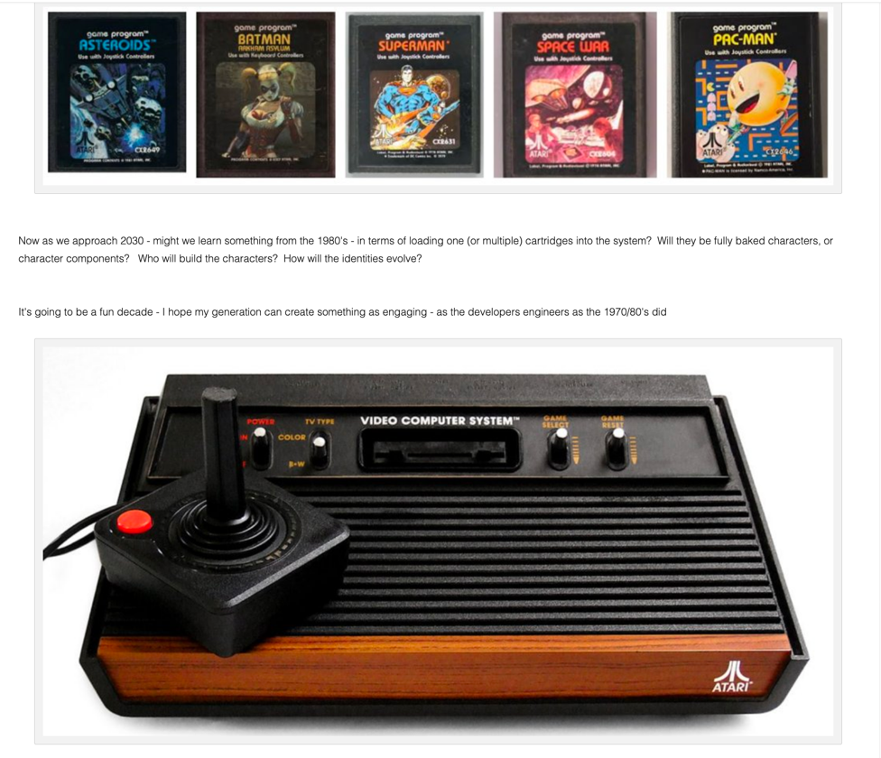

I grew up in the late 70’s and early 80’s. Stranger Things indeed. At the time, the state of the art for electronic tech (when not playing D&D) was Atart, Intellivision and ColecoVision. The beauty of Atari and similar systems is once you decided on the game - you could grab the physical game cartridge and slam it into the console. Then flip on the system. 80% of the time it would fire up - the other 20% you'd need to re-seat the cartridge (jiggle and retry) which usually worked

Now as we approach 2030 - might we learn something from the 1980's - in terms of loading one (or multiple) cartridges into the system? Will they be fully baked characters, or character components? Who will build the characters? How will the identities evolve?

It's going to be a fun decade - I hope my generation can create something as engaging - as the developers engineers as the 1970/80's did

Story and Narrative Generation

Scene and Event Auto-creation

Game Level Spontaneous Generation

Game Difficulty Auto-Tuning

Personalization & Segmentation

PART 2 - Proof of Concept - The Observers

(Oct 2018)

If we imagine an experiment

Three Different "Character Types" created from (1b) bootstrap from real person or blend of people (e.g. JFK plus Ronald Reagan; or (1a) Character Template archetype)

The CHARACTERS (2) can be thought of as "Observing Bots" - the watchers . No chat, no dialog required. but they do Watch. have emotional states (3) that are impacted by the Data/Traffic/Chatter/Context of Situation (4) - and differing REACTIONS (8) on how they see the world. different lenses

OBSERVABLE world - the data - could be call center traffic, twitter streams, a twich channel in esports, unstructured observable data that is sliced along time domain (6) and analyzed (7) using standard and/or custom tools like NLC NLU NLP Tone extraction, and/or ML/DL filters

INTERPRETER considers information in front from (7) along with Character Type (2) ; Emotional State at a moment in time (3) (e.g. is the Character already upset or angry?; and (4) Context - e.g. is it appropriate to use profanity workplace (no) ; or with friends at pub (perhaps yes);

SYSTEM SUM of signals - will result in some feedback on Emotional State (3) and MIGHT result - near term in simply setting a flag; if a TRIGGER (10) is reached

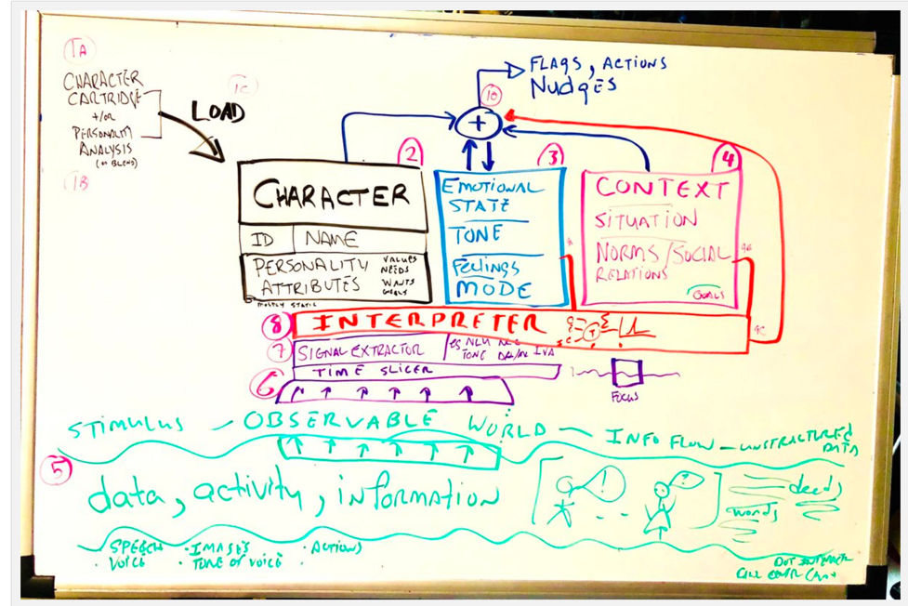

Playing with A POC:

THREE Different Characters

Obersving Agents (they WATCH and they CHANGE (respond change of state), but they dont talk/act) -

We "Watch the Watchers" - and ntoe the differences

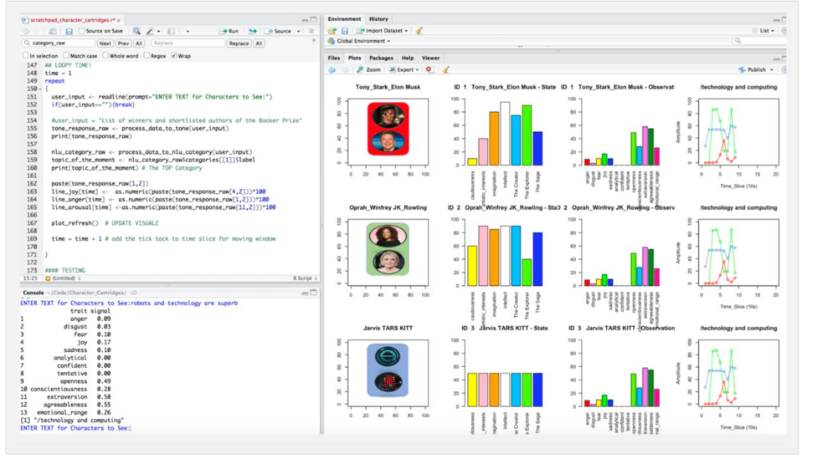

<https://youtu.be/E-La91wr8xw>

# 19. Conversation Starters: Emerging Technologies in Media & Entertainment

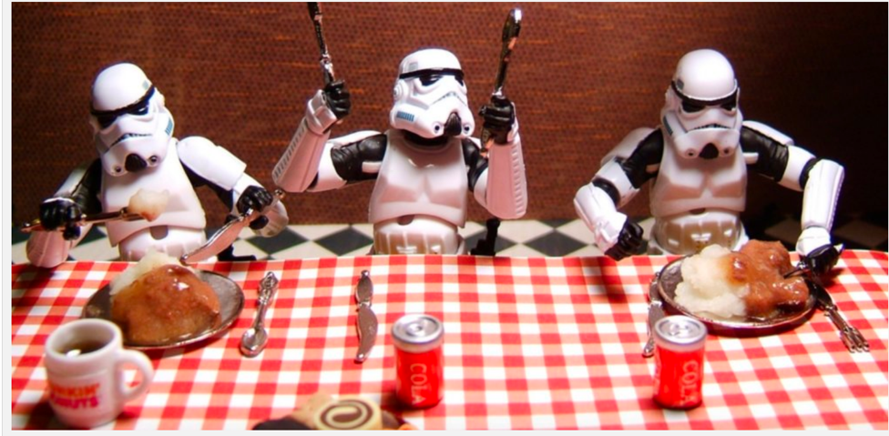

I've been having more and more conversations that touch on the intersection of Media and Entertainment; and emerging technologies like Augmented Reality and AI in Digital Humans.

I jotted down a few 'conversation starters' - thought I'd share them. And a caveat - I'm not a domain expert on below (I'm not sure any exist) - but rather a curious explore.

Evolution of Storytelling: Augmented Reality, Virtual Reality & First/Shift Person

Storytelling is Evolving - Within Media and Entertainment, the number of distribution vectors continues to grow, as do the differing forms of story experiences. Non-linear choose-your-own-adventure stories on Netflix; Augmented Reality Star Wars Storm-troopers on iPhones, Virtual Reality immersive games and first person and “shift person” stories. The sector is experiencing a period of punctuated evolution.

Foundation Artificial Intelligence & Cognitive Computing

Cognitive Test Kitchen - Rapid advances in Cognitive Computing and Artificial Intelligence are accelerating innovation in consumer goods, enterprise, and entertainment. Using the metaphor of a well-equipped ‘test kitchen’ we discuss how the technology ingredients can be used for exploration and innovation – developing recipes to move from cupcakes to wedding cakes.

Skills Building – Expanding Studio Capabilities through 2050

Skills Building - Agencies and studios wishing to compete in a rapidly evolving “new-media” space will need to build capabilities and culture to foster evolution. The type and composition of talent require to deliver non-traditional media in 2050 will differ greatly from present day. Storytellers will need to expand skills, and create connections to technologists, and leverage technology without losing the core artistic and storytelling elements. In this section we explore ‘what might be’ by examining early adopters – and lessons learned from successes & failures.

Digital Humans and Digital Assistants – An Evolution of Technology & Ideas

Widely adopted Conversational Agents such as Amazon’s Alexa, have set the stage for more sophisticated Digital Humans and Digital Assistants. What was once pure science fiction (KITT, HAL, Ash, JARVIS, and TARS) now seem closer than ever. As the space matures to a second generation “Cognitive Wingman” – we explore questions such as: What will they look and sound like? How will they emote and behave? How much access to personal information should they have?

Architecting Empathetic Systems – Empathy & Emotional Intelligence

We explore the degree to which Identity, Empathy and Emotional Intelligence, can support use cases and enhance a user’s experience. Signal extraction services such as tone and emotion analyzer, natural language understanding, custom Natural Language Classification models, sentiment analysis, alongside standardized personality model and type mapping, can provide systems to adjust to the emotion of user, and in cases, emulate emotions and emotional responses.

Characters and Content – New World and New Channels

Studios and Media Conglomerates own characters worth billions of dollars. For example, Marvel Cinematic Universe (MCU) purchased by Disney in 2009 for $4b and has grossed more than $11b at the box office. We explore how evolving technology and media vectors are potential opportunities for studios character assets, to unlock potential – from both user experience and financial aspects. Is having your own augmented reality "Jarvis" as a cognitive wingman an appealing value proposition? if so, how valuable, and why?

# 20. IBM Watson + Unity Hello Virtual World 4 EMOTIONAL AVATAR

<https://youtu.be/fOfFrGsNwHo>

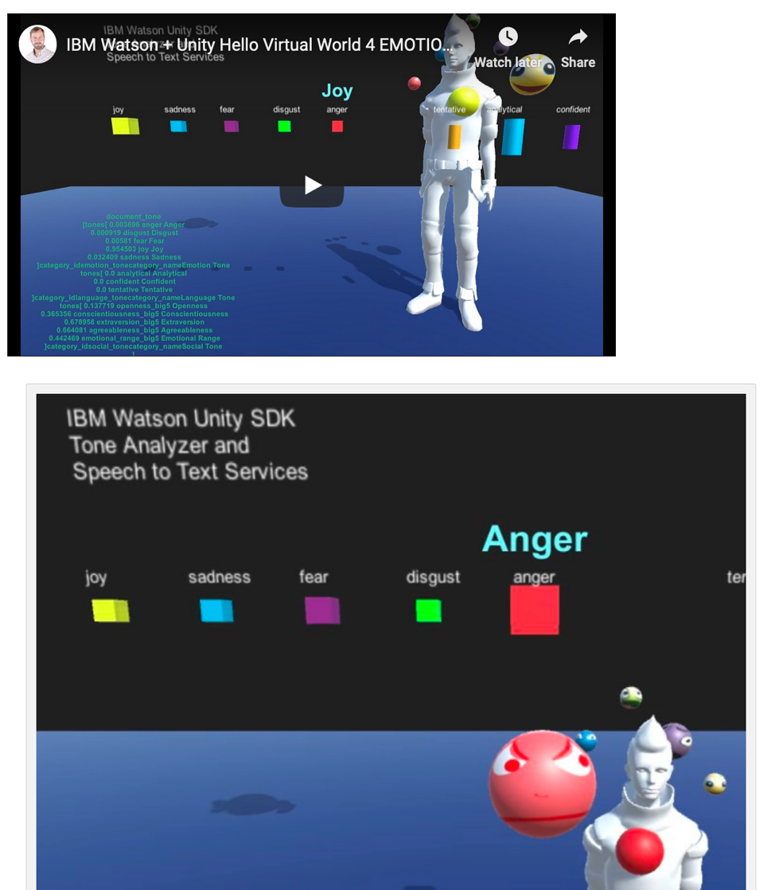

# 21. Improve Learning Outcomes for Spectrum Edge Learners

<https://dreamtolearn.com/ryan/cognitivewingman/21>

Identifying Knowledge Milestones to Improve Learning Outcomes for Spectrum Edge Learners

PUBLIC SAFE

Overview

The current education system is primarily focused on the approximately 85-90% of students who are typical learners, and who respond well to typical curricula. Many students do not fit into this category – the “spectrum learners”; they include:

· Variety of students on the Autism Spectrum (~2%) who need a more nuanced approach

· Gifted students (~6%) bored under-challenged, leading to a failure to thrive to potential

· Other Students with atypical learning styles, failing to thrive with conventional curriculum

The solution helps identify critical path knowledge milestones and optimal paths to improve learning outcomes for spectrum learners. For this summary, we focus autistic learners.

Key Elements of Solution:

1. Augments known educational best practices (learning outcomes, learning pathways) with insights gained from ML/DL analysis combined with traditional data science

2. Leverages dynamic segmentation and clustering (cohorts, archetypes)

3. Uses deep learning to surface key features in natural language and knowledge set / ontology

4. Uses Machine Learning (e.g. Random Forest) to surface key features in learning path

5. Applies Natural Language Understanding for signal extraction from students & teachers

6. Interacts – Provides natural language and visual interactions to exchange information, including but not limited to Augmented Reality, Virtual Reality and Digital Humans.

7. Learns. Evolves with the content, learners and teachers to improve over time

Using the solution and elements above, along with established teaching methods – we can compose a dynamic Sensemaking System data driven analysis of what factors lead to successful learning outcomes.

Proposal: By identifying key components in learning journeys (using prior knowledge of learning outcomes, and other learning journeys) the system will permit Teachers, Parents and Students to understand and address knowledge and learning gaps most likely to increase the likelihood of success and learning outcomes.

Hypothesis: With the system described we believe we can create an improvement (KPI%-TBD) learning outcomes for students with autism, when compared to those not leveraging solution

Advantages:

The advantage of this system is that it can take a holistic view of thousands of learning journeys, and identify the factors that are impactful to positive/negative learning outcomes, and then (a) surface information for teachers and/or (b) dynamically adjust content or user experience to help the student accomplish the critical path items.

Required:

a) Ontology and Content Extraction

a. Leveraging NLU and Data Science methods to tag and cluster a wide variety of Knowledge, Ideas, Concepts and teaching delivery methods, not previously mapped, nor available to analytics. (Data and Corpus ingestion and curation)

b. Modeling and Clustering

c. Surfacing content, components and ideas that are candidates for benefitting some cohorts of learnings

d. user interface / visualization

b) Modeling of Learning Flows

a. mapping covering majority of types;

b. user interface / visualization – possibly leveraging cognitive/spatial for students and teachers – visualizing gaps; alternate pathways

c) Analytics

a. Sequence Analysis / Flag Detection - potentially informative flags, signals and insights to teachers. For example, if another SEQUENCE of learning or method proved to be 3X more effective for learner type ABC – system could suggest exploring alternate method, content or sequence

4. Description:

STEP 1: Analyze Students and Cluster into multiple Cohorts based on all available data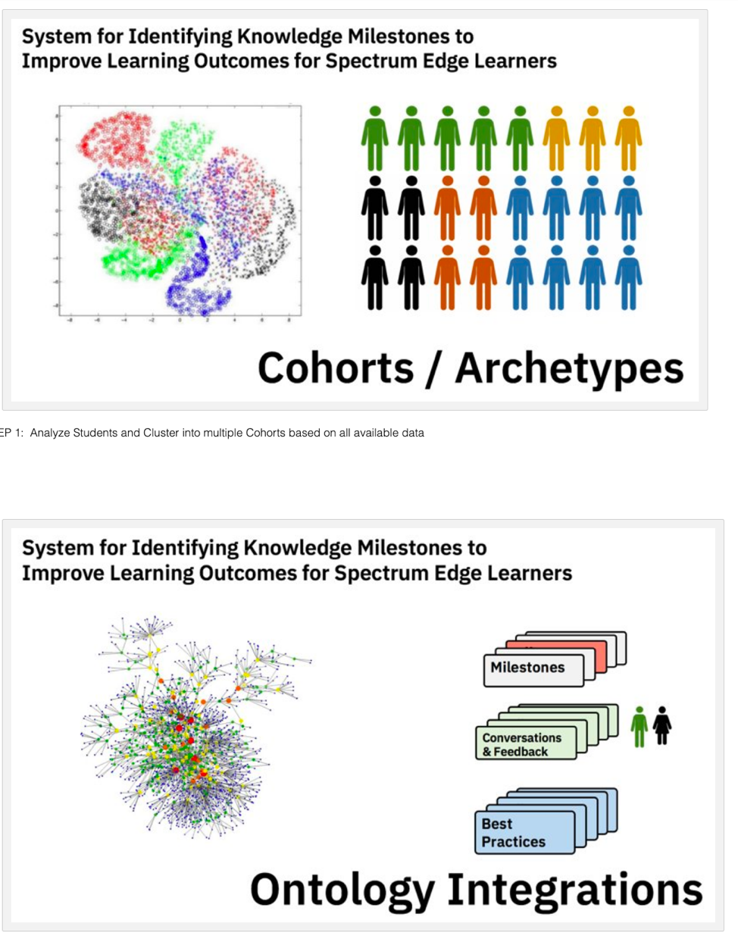

STEP 2: Analyze Content of Learning, Curricula, Conversations, Teacher/Therapist Notes

STEP 3: Produce a Simplified Knowledge Journey (by cohort), segment by outcomes

STEP 4: Manually (initially) develop Preferred Path and content – best fit for cohort

STEP N: On wide deployment (Phase 3+) – Consider Digital Humans as mechanism to (a) improve information coming from Student; Teacher; Therapists; and (b) as alternate-path cognitive assistant

(Image source: soul machines web site, just used as a digital human example - see also faceme or unity models)

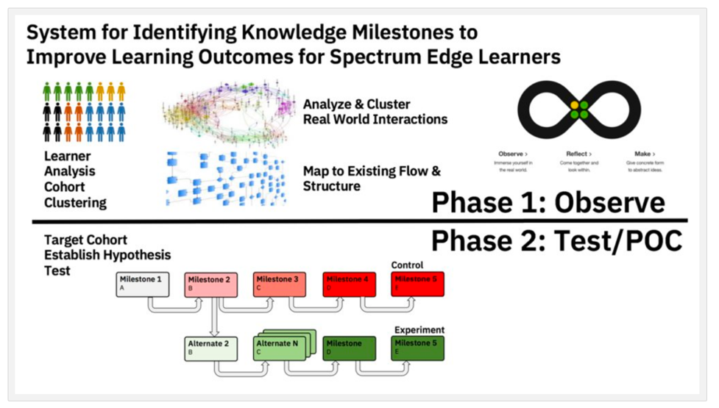

SUMMARY: Two phase process – Phase 1 is Data Analysis and Developing Test; Phase 2 POC

KEY IDEAS TO EXPLORE:

a) DEEP LEARNING / MACHINE LEARNING – automated system will continually re-evaluate based on features (students, cohorts and content/knowledge) to flag essential components and/or engage student or teacher to improve on it

b) EMPATHY / FRAME OF REFERENCE (POV) – modify curricula to reflect the differing perspectives of learners – use ML/DL feature extraction and prediction to elevate importance of most impactful knowledge milestones depending on the cohort and success factors for similar learners;

c) PIVOTAL IDEAS / FLAGS – discovering high-power concepts, ideas, methods and surfacing for wider community to assess, and/or test – methods of automation for validation

d) VISUAL GATES REPRESENTED BY DIGITAL HUMANS (narrow domain) – e.g. UX interaction in Augmented Reality with a cognitive wingman – verbal conversation to solicit information; signal and help in mastery of concept using different methods (at scale) to understand best fit for Cohort/type

REALTED READING:

https://www.slideshare.net/BilinguisticsInc/using-dynamic-assessment-in-differential-diagnoses-of-culturally-esk-powerpoint-show

0 Comments

# 22. Six Thinking Hats Classifier? Character Cartridge?

<https://dreamtolearn.com/ryan/cognitivewingman/22>

Six distinct directions are identified and assigned a color. The six directions are:

* **Managing** Blue – what is the subject? what are we thinking about? what is the goal? Can look at the big picture.
* **Information** White – considering purely what information is available, what are the facts?
* **Emotions** Red – intuitive or instinctive gut reactions or statements of emotional feeling (but not any justification).
* **Discernment** Black – logic applied to identifying reasons to be cautious and conservative. Practical, realistic.
* **Optimistic response** Yellow – logic applied to identifying benefits, seeking harmony. Sees brighter side of situations.
* **Creativity** Green – statements of provocation and investigation, seeing where a thought goes. Thinks creatively, outside the box.

<http://www.debonogroup.com/six_thinking_hats.php>

<https://en.wikipedia.org/wiki/Six_Thinking_Hats>

# 23. Beyond Verbal’s API analyzes the ACOUSTIC traits of utterances

<http://www.beyondverbal.com/api/>

kicking tires below

my GH repo with test files here:

[**https://github.com/rustyoldrake/call_center_instrumentation_analytics**](https://github.com/rustyoldrake/call_center_instrumentation_analytics)

* Sadness/Uncertainty/Boredom

* Anger/Dislike/Stress

* Neutral

* Happiness/Enthusiasm/Friendliness

* Warmth/Calmness

A key indicator of a speaker’s emotional state during the analyzed voice section, ranging from anger, sadness and neutrality to happiness and warmth

Valence is a variable which ranges from negativity to positivity. When listening to a person talk, it is possible to understand how “positive” or “negative” the person feels about the subject, object or event under discussion.

Arousal is a variable that ranges from tranquility/boredom to alertness/excitement. It corresponds to similar concepts such as level of activation and stimulation.

Temper is an emotional measure that covers a speaker’s entire mood range. Low temper describes depressive and gloomy moods. Medium temper describes friendly, warm and embracive moods. High temper values describe confrontational, domineering and aggressive moods.

Links <http://developers.beyondverbal.com/Home/Index> <http://developers.beyondverbal.com/Home/api> <https://github.com/BeyondVerbal-V3> <https://github.com/BeyondVerbal-V3/Python>

audio record Recorded Audio in Quicktime, then opened with ITUNES then converted to WAV

first error WAV format Ryans-MBP-4:Python ryan$ python BVC.py {u'status': u'failure', u'reason': u'The API requires WAV PCM 8 KHz, 16 bit Mono'} so went to itunes>preferences>general>import>WAV>Custom>8khz & 16bit mono

Each time manually updated file:

# audio_test_enthused_friendly.wav

yeah. Yeah thank you for taking my call. I need to change my phone number. My new number is 5551234. Yeah. And my new address is. 678 oak street. In Denver Colorado. Yes mmhm. Very yep. And yes I still have my ritual car. Very good thank you for helping me change that. By.

{u'status': u'success', u'recordingId': u'43c8064e-a326-4df8-8c51-13dbf6d76990', u'result': {u'duration': u'34526.63', u'analysisSegments': [{u'duration': 13420, u'analysis': {u'Arousal': {u'Group': u'low', u'Value': u'7.23', u'Summary': {u'Mode': u'low', u'ModePct': 100}}, u'Valence': {u'Group': u'positive', u'Value': u'84.24', u'Summary': {u'Mode': u'positive', u'ModePct': 100}}, u'Temper': {u'Group': u'low', u'Value': u'8.59', u'Summary': {u'Mode': u'low', u'ModePct': 100}}, u'Vad': {u'Voiced': u'6.96'}, u'Mood': {u'Group11': {u'Primary': {u'Phrase': u'Loneliness, Unfulfillment', u'Id': 7}, u'Secondary': {u'Phrase': u'Loneliness, Unfulfillment', u'Id': 7}}, u'Composite': {u'Primary': {u'Phrase': u'Striving for love or belonging.', u'Id': 16}, u'Secondary': {u'Phrase': u'Fear of abandonment. Love and lack of self-confidence.', u'Id': 214}}, u'Group21': {u'Primary': {u'Phrase': u'loneliness', u'Id': 16}, u'Secondary': {u'Phrase': u'loneliness', u'Id': 16}}}}, u'offset': 16}, {u'duration': 14580, u'analysis': {u'Arousal': {u'Group': u'low', u'Value': u'1.20', u'Summary': {u'Mode': u'low', u'ModePct': 100}}, u'Valence': {u'Group': u'neutral', u'Value': u'37.21', u'Summary': {u'Mode': u'neutral', u'ModePct': 50}}, u'Temper': {u'Group': u'low', u'Value': u'8.04', u'Summary': {u'Mode': u'low', u'ModePct': 100}}, u'Vad': {u'Voiced': u'8.80'}, u'Mood': {u'Group11': {u'Primary': {u'Phrase': u'Loneliness, Unfulfillment', u'Id': 7}, u'Secondary': {u'Phrase': u'Loneliness, Unfulfillment', u'Id': 7}}, u'Composite': {u'Primary': {u'Phrase': u'Loneliness, fatigue, emotional frustration.', u'Id': 79}, u'Secondary': {u'Phrase': u'Striving for love or belonging.', u'Id': 16}}, u'Group21': {u'Primary': {u'Phrase': u'loneliness', u'Id': 16}, u'Secondary': {u'Phrase': u'loneliness', u'Id': 16}}}}, u'offset': 14826}], u'analysisSummary': {u'AnalysisResult': {u'Arousal': {u'Mode': u'low', u'ModePct': 100}, u'Valence': {u'Mode': u'neutral', u'ModePct': 50}, u'Temper': {u'Mode': u'low', u'ModePct': 100}}}, u'sessionStatus': u'Done'}}

# audio_test_angerdislike.wav

Yeah I need to change my address yeah. Yeah my number 2. No I don't. My new number is 5551234. No yes. My new address is 678. Come St. And yet I still got the car. Yeah okay thanks for help. By.

{u'status': u'success', u'recordingId': u'31753631-f8f5-41fb-9d3b-08c34c7b9aa9', u'result': {u'duration': u'28698.38', u'analysisSegments': [{u'duration': 13790, u'analysis': {u'Arousal': {u'Group': u'low', u'Value': u'8.51', u'Summary': {u'Mode': u'low', u'ModePct': 100}}, u'Valence': {u'Group': u'negative', u'Value': u'15.19', u'Summary': {u'Mode': u'negative', u'ModePct': 100}}, u'Temper': {u'Group': u'low', u'Value': u'12.01', u'Summary': {u'Mode': u'low', u'ModePct': 100}}, u'Vad': {u'Voiced': u'6.15'}, u'Mood': {u'Group11': {u'Primary': {u'Phrase': u'Sadness, Sorrow', u'Id': 9}, u'Secondary': {u'Phrase': u'Defensivness, Anxiety', u'Id': 3}}, u'Composite': {u'Primary': {u'Phrase': u'Remorseful. Conflict of reason and passion.', u'Id': 121}, u'Secondary': {u'Phrase': u'Pain, vulnerability, need to fight.', u'Id': 40}}, u'Group21': {u'Primary': {u'Phrase': u'loneliness', u'Id': 16}, u'Secondary': {u'Phrase': u'unhappiness', u'Id': 21}}}}, u'offset': 16}, {u'duration': 14590, u'analysis': {u'Arousal': {u'Group': u'low', u'Value': u'5.62', u'Summary': {u'Mode': u'low', u'ModePct': 100}}, u'Valence': {u'Group': u'negative', u'Value': u'9.47', u'Summary': {u'Mode': u'negative', u'ModePct': 100}}, u'Temper': {u'Group': u'low', u'Value': u'13.97', u'Summary': {u'Mode': u'low', u'ModePct': 100}}, u'Vad': {u'Voiced': u'7.01'}, u'Mood': {u'Group11': {u'Primary': {u'Phrase': u'Sadness, Sorrow', u'Id': 9}, u'Secondary': {u'Phrase': u'Self-Control, Practicality', u'Id': 10}}, u'Composite': {u'Primary': {u'Phrase': u'Disappointment.', u'Id': 124}, u'Secondary': {u'Phrase': u'Restrained communication through self-control.', u'Id': 169}}, u'Group21': {u'Primary': {u'Phrase': u'unhappiness', u'Id': 21}, u'Secondary': {u'Phrase': u'self control', u'Id': 19}}}}, u'offset': 13816}], u'analysisSummary': {u'AnalysisResult': {u'Arousal': {u'Mode': u'low', u'ModePct': 100}, u'Valence': {u'Mode': u'negative', u'ModePct': 100}, u'Temper': {u'Mode': u'low', u'ModePct': 100}}}, u'sessionStatus': u'Done'}}

# audio_test_boredsad.wav (poor audio quality)

Yeah. On number. All. All. Yeah. Phone number. That is what we. Yeah don't. The money involved. Yeah. Thank you for help.

{u'status': u'success', u'recordingId': u'dbfdd24c-e3a9-432c-8912-73945abb05bb', u'result': {u'duration': u'43698.50', u'analysisSegments': [{u'duration': 13260, u'analysis': {u'Arousal': {u'Group': u'low', u'Value': u'9.65', u'Summary': {u'Mode': u'low', u'ModePct': 100}}, u'Valence': {u'Group': u'neutral', u'Value': u'53.27', u'Summary': {u'Mode': u'neutral', u'ModePct': 100}}, u'Temper': {u'Group': u'low', u'Value': u'14.48', u'Summary': {u'Mode': u'low', u'ModePct': 100}}, u'Vad': {u'Voiced': u'4.65'}, u'Mood': {u'Group11': {u'Primary': {u'Phrase': u'Sadness, Sorrow', u'Id': 9}, u'Secondary': {u'Phrase': u'Loneliness, Unfulfillment', u'Id': 7}}, u'Composite': {u'Primary': {u'Phrase': u'Helplessness.', u'Id': 139}, u'Secondary': {u'Phrase': u'Striving for love or belonging.', u'Id': 16}}, u'Group21': {u'Primary': {u'Phrase': u'inferiority', u'Id': 15}, u'Secondary': {u'Phrase': u'loneliness', u'Id': 16}}}}, u'offset': 16}, {u'duration': 18250, u'analysis': {u'Arousal': {u'Group': u'low', u'Value': u'13.89', u'Summary': {u'Mode': u'low', u'ModePct': 100}}, u'Valence': {u'Group': u'neutral', u'Value': u'58.12', u'Summary': {u'Mode': u'neutral', u'ModePct': 100}}, u'Temper': {u'Group': u'low', u'Value': u'15.19', u'Summary': {u'Mode': u'low', u'ModePct': 100}}, u'Vad': {u'Voiced': u'4.43'}, u'Mood': {u'Group11': {u'Primary': {u'Phrase': u'Defensivness, Anxiety', u'Id': 3}, u'Secondary': {u'Phrase': u'Love, Happiness', u'Id': 8}}, u'Composite': {u'Primary': {u'Phrase': u'Pain, vulnerability, need to fight.', u'Id': 40}, u'Secondary': {u'Phrase': u'Love, possessiveness from insecurity.', u'Id': 412}}, u'Group21': {u'Primary': {u'Phrase': u'unhappiness', u'Id': 21}, u'Secondary': {u'Phrase': u'love', u'Id': 17}}}}, u'offset': 13826}], u'analysisSummary': {u'AnalysisResult': {u'Arousal': {u'Mode': u'low', u'ModePct': 100}, u'Valence': {u'Mode': u'neutral', u'ModePct': 100}, u'Temper': {u'Mode': u'low', u'ModePct': 100}}}, u'sessionStatus': u'Done'}}

# 24. IBM Virtual Voice Creator - Character Voices

<https://ivva-tts.sl.haifa.il.ibm.com/design>

The IBM Virtual Voice Creator takes Text-To-Speech (TTS) synthesis technology to the next level, letting enterprise customers and users create unique voice personas on-demand in a fast and easy way. The IBM Virtual Voice Creator lets you automatically create a voiceover for a multi-character game, animation or educational video, without the hassle of hiring voice actors and audio recording studios. [http://www.research.ibm.com/haifa/dep...](https://www.youtube.com/redirect?event=video_description&v=RfmM5PWXaHU&redir_token=dlkKkp6GGWZQbuHZ9DXYHKJ3tX98MTUyMjI2OTA2MUAxNTIyMTgyNjYx&q=http%3A%2F%2Fwww.research.ibm.com%2Fhaifa%2Fdept%2Fimt%2Fivvc.shtml) "The beta-service is available until Aug 10, 2018"

<https://youtu.be/RfmM5PWXaHU>

25. Using AI for AI: Exploring AI Architectures and Frameworks for Authentic Interactions in Theme Parks

Full Deck here PDF:

<https://drive.google.com/file/d/1WD5mhDfz01TvE7GwfuU483PMaY499Vfu/view?usp=sharing>

•**“Animate” Characters**

•Conversations

•Continuity

•Emotion & Identity

•**Content**

•Stories.  Moments.  Connections.

•Frameworks for ‘day long interactions’

•**Personalization**

•Sensemaking systems “know you”

•Flavors of people.

•Role playing and Fantasy.  Imagine.

•**Brand Amplification**

•Surface more characters (e.g. MCU)

•Monetization options

•**Venue / Crowd Management**

•Dynamic Load Balancing

**26. Decision Support Framework 2050**

When contemplating the kinds of high-impact DECISION SUPPORT tools for national or international organization we consider

(1) the need for a sophisticated data discovery and decision support tool; and

(2) agencies/stakeholders can create positive change in the world.

The concepts below explore and IDEAL DECISION SUPPORT FRAMEWORK for the most ambitious problems. In 30 years (by 2050) what might such a system comprise? And for what global challenges?

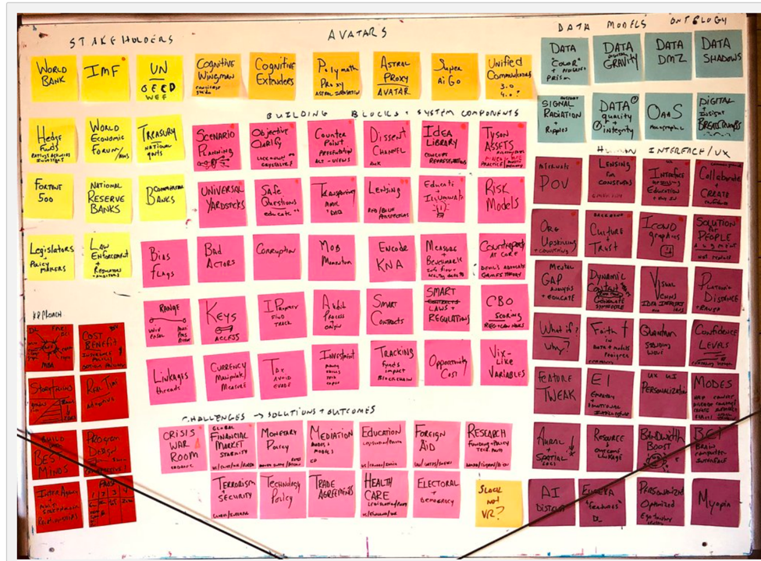

Framing the Solution Space:

YELLOW = STAKEHOLDERS

ORANGE = AVATARS & AGENTS -

BLUE = DATA MODELS

HOT PINK = BUILDING BLOCKS

PURPLE = HUMAN INTERFACE & UX

LIGHT PINK = CHALLENGES, SOLUTION TARGETS

RED = PROGRAM APPROACH

# DATA MODELS

1. Data Color and Shape - Data examined through lenses and prisms  (sensemaking & understanding)
2. Data gravity.  Impact.  Distance.
3. Data DMZ - Safe Area / Stakeholder (safe) sharing of key elements
4. Data shadows upon other data / knowledge graphs.
5. Signal Radiation and Ripples – across the time domain (and visualized 2d surface or 3D) the impact of risk or dependencies
6. O* Digital Breadcrumbs

# HUMAN INTERFACE & UX

1. Lensing - showing multipe perspectives;  "Rotating" an idea 90 degrees
2. Collaboration & Creation - mechaisms to support multiple people engaging with same ideas
3. Symbols and Icons - Semiotics ; representations of data, models and ideas as symbols
4. Visual Venn Diagrams to crisply illustrate idea intersections
5. Culture and Trust as essential components to collaboration.  Ethics and transparency
6. Platonic Distance - using the platonic form as a reference point for other ideas.
7. Faith in data and models; and how to represent faith vs fact based positions
8. Spatial placement of ideas
9. Personalized Optimized

# BUILDING BLOCKS

1. Scenario Planning
2. Objective Clarification
3. Counterpoint Representation
4. Dissent Channel <https://fam.state.gov/fam/02fam/02fam0070.html>
5. Idea Library - Knowledge Shorthand / Lego
6. Tyson Assets -  <https://www.brainyquote.com/quotes/mike_tyson_382439>
7. Universal Yardsticks
8. Safe Questions to Educate
9. Transparency - Models & Data
10. Lensing - Red/Blue Perspectives
11. Educate & Illuminate
12. Risk Models
13. Bias Flags
14. Bad Actors
15. Corruption
16. Mob Momentum
17. Encode KNA - String
18. Measure & Benchmark
19. Counterparty at Core
20. Range - global to personal
21. Keys and Access
22. Property Find track
23. Audit Process & Origin
24. Smart Contracts
25. Smart Laws & Regulations
26. CBO Scoring / Metrics
27. Linkages / Threads
28. Currency & Wealth
29. Tax Avoidance Evasion
30. Investment Frameworks
31. Tracking Impact
32. Opportunity Cost
33. VIX Like Variables

# CHALLENGES, SOLUTION TARGETS

1. Crisis War Room
2. Global Financial Market Stability
3. Monetary Policy
4. Mediation
5. Education Policy
6. Foreign Aid
7. Research Funding & Policy
8. Terrorism & Security
9. Technology Policy
10. Trade Agreements
11. Health Care
12. Electoral & Democracy

# PROGRAM APPROACH

1. MBA Best Practices
2. Cost Benefit
3. Storytelling
4. Real Time
5. Best Minds - Compose
6. Program Design
7. Inter Agency
8. Phased Approach

**27. Storytelling & Knowledge Capture**

PART 1 -

How can STORIES be used to capture, analyze, interpret and ultimately use organizational knowledge?

Digging a little deeper here – this is a follow up blog to last year (April 2017) on Digital Twins & Digital Threads: A Holistic Approach to Asset Management that covered

· Human Insights & Tribal Knowledge

· asset-centric knowledge capture

· ROI and Risk Management – with Digital Twin & Digital Threads

· https://dreamtolearn.com/ryan/data_analytics_viz/111

Why do we care? Here's one example from the United States Nuclear Regulatory Commission (NRC)

“The United States Nuclear Regulatory Commission (NRC) has practiced the capturing, preservation, sharing, and use of organizational knowledge long before the term Knowledge Management (KM) came into common use. However, it was not until 2006 with the establishment of a formal KM program with a clear system of governance that the NRC initiated a more structured and systematic approach to KM. The primary impetus at the time was the changing demographics of NRC’s workforce and the recognition that a significant percentage of NRC’s highly skilled and knowledge able workforce was poised for retirement; plus the NRC was in a rapid growth mode in which large numbers of new employees were being hired and needed to become qualified as license reviewers and inspectors. It was a high priority to capture and preserve the knowledge of our aging workforce and transfer it to others, especially to the newly hired employees.”

Let’s start by unpacking Storytelling into four chunks

1. GATHER

2. ANALYZE

3. INTERPRET

4. UTILIZE

(1) GATHER

Here we cast the net wide. Gathering information from documents, transcripts, or anywhere where there is a story to be told. Engaging the humans in the organization. Interviewing. Listening. Could also be transcribing audio from conference calls or incidents - or a fireside-chat style recording while drinking a beer with a veteran.

The stories will vary. Some will contain organizational knowledge. Others touch on culture, traditions or hierarchy. Others may be some lessons learned the hard way or home truths.

This can be thought of as a human-API (hAPI?) – to tap, solicit, mine or infer information

(2) ANALYZE

Once the raw materials are at hand – the central themes and ideas can be examined. Some stories with structure will surface – with characters, plot, and outcomes. Others may be fragments.

The Characters are key – human elements – that may contain archetypes, identities, emotions and personalities. An analysis step may seek to surface relevant factors like “power distance” between characters. I.e. For a story with a CEO interacting with an intern, the power distance might be an integral part.

Analysis can also include standard signal extraction – NLU/NLP/NLC and concept extraction. Story types, “shape” and topology. Story staking and mapping. Ultimately the analysis helps move information the way up the DIKW flow – Data > Information > Knowledge and Wisdom .

(3) INTERPRET

Reading the tea leaves is next. This may include human touch – at least in early days.

Tagging and Marking. Pattern analysis (e.g. clustering and weights)

For the more ambitious – the platonic form of story, or key concepts can be distilled. The essence of the story. This may include semiotic or symbolic represenations, and/or metaphor.

The interpretation of the information should be tied back to KPIs for the organization and mission flags – i.e. start to connect the dots to ‘why does this matter?’

(4) UTILIZE

Lastly – what is to be done with the stories, knowledge and insights?

The Human Computer Interrace (natural language, often verbal ) is key – to understand how the knowledge may be used. And useful.

The solution may generate useful guidance – uses may include, training, facilitation, deictions support, or solicitation of guidance.

Alerts and Assistance – system alerts or reminders may be part of usefulness too

Real World Examples:

Nuclear - multi-generational knowledge transfer (risk)

Energy & Transportation - any other mulit-decade knowledge transfer (rolling stock, signal switching, oil & gas platforms, infrastructure

Therapy - PTSD / Dementia - Story clustering to find best fit.

Education - finding most resonant flavors of storys - for each learner TYPE

etc..

Use Case (Railways)

I had the opportunity to interview a respected railway executive and retired project director. He has nearly 50 years of experience with the design, delivery and operation of a large and complex railway systems.

He told me a very interesting story of how his organization got exceptional value out of its rolling stock. KPIs almost unbelievable to people outside the company. Although the typical asset life span of rolling stock was 30 years; his organization has safely extended it to 40, and in some cases nearly 50 years. Keep in mind some of these rail cars were built just after I was born, and are still safely in operation today.

His railway was able to do this because of a unique combination of company culture; tribal knowledge; great (old school) record keeping; and top-shelf engineering and maintenance teams. In this case, quality data and knowledge of the rolling stock (and refurbishment investment), resulted in asset life extension of more than 60%...

Appendix

Structure of Myth (Levi-Strauss)--Symbols & Society https://www.youtube.com/watch?v=42QwA0NOTX4

PART 2 - Reflections

My friend Chris Noessel https://twitter.com/chrisnoessel?lang=en and I spoke to a customer on this topic last week - and expanded on this idea. I really enjoyed working with Chris on Storytelling about Storytelling - fresh perspectives.

Storytelling, considering...

- Community

- Purpose & Value

- Typology

- Methods

We talked about WHISKEY JACK - a fictional character who has been working in the energy sector for decades. About to retire. Knows the history of assets, knows what works from the 'official' engineering manuals - but also has developed a WEALTH OF KNOWELDGE (hard won) from years of adapting to extreme conditions. We asked "when Jack Retires, how much valuable knowledge LEAKS out the door? HOw might we slow the knowledge leaking?" - (hint: it involves buying Jack drinks and talking to him.. getting the kinds of stories you might not get in a formal exit interview, or engineering notes)

We talked about PURPOSE of stories..

He went deep on TYPOLOGY in stories ("study of or analysis or classification based on types or categories") - picking up on this concept https://www.theatlantic.com/technology/archive/2016/07/the-six-main-arcs-in-storytelling-identified-by-a-computer/490733/ but understanding that there are DOZENS of Typologies - depending on perspectives and objectives of stakeholders...

and the loop from Individuals with a common purpose, and how that evolves to collective intelligence (some implicit) that nests, back to individuals...

AI / Technology is not a Silver Bullet

We also cautioned that TECHNOLOGY, in many use cases may only be a small part of a project - especially in early stages of a project. For example - if stakholders are resistant to speaking, or there are few stories of practical use - no amount of technology can surface signal where it does not exist.

In short - AI might be a powerful catalyst, but it's not a silver bullet - and it's just one part.

StoryCorps

I love this "old school" image if you dont konw StoryCorps - check out background here https://en.wikipedia.org/wiki/StoryCorps - the organization has a "mission is to record, preserve, and share the stories of Americans from all backgrounds and beliefs" - and this photo could be from 2 years ago, or 20 years ago...

Unpacking management tasks in Storytelling Projects..

1. Capturing

2. Prompting

3. Analyzing

4. Disseminating

5. Organizational change: habituation

Anyway - we're planning on co-creating a proper blog - but just wanted to get the key points down so I dont forget - and as a memory trigger..

to be continued...

# 28. Agents, Agency & Collective Intelligence - The Mother of All Reading Lists

<https://dreamtolearn.com/ryan/cognitivewingman/28>

# MORL - the Mother of All readling lists...

## covering Agents, Agency and Collective Intelligence

with sincere thanks to a wise mentor, whose generosity is rivaled only by the richness of his library

**Multiagent Systems: Algorithmic, Game-Theoretic, and Logical Foundations (*)**

<https://www.amazon.com/Multiagent-Systems-Algorithmic-Game-Theoretic-Foundations-ebook/dp/B009019YVQ/>

Multiagent systems combine multiple autonomous entities, each having diverging interests or different information. This overview of the field offers a computer science perspective, but also draws on ideas from game theory, economics, operations research, logic, philosophy and linguistics. It will serve as a reference for researchers in each of these fields, and be used as a text for advanced undergraduate or graduate courses. The authors emphasize foundations to create a broad and rigorous treatment of their subject, with thorough presentations of distributed problem solving, game theory, multiagent communication and learning, social choice, mechanism design, auctions, cooperative game theory, and modal logics of knowledge and belief. For each topic, basic concepts are introduced, examples are given, proofs of key results are offered, and algorithmic considerations are examined. An appendix covers background material in probability theory, classical logic, Markov decision processes and mathematical programming.

**Understanding Agent Systems (Springer Series on Agent Technology)**

<https://www.amazon.com/Understanding-Agent-Systems-Springer-Technology/dp/3540407006>/

...a formal approach to dealing with agents and agent systems in this second edition of Understanding Agent Systems. The Z specification language is used to establish an accessible and unified formal account of agent systems and inter-agent relationships. In particular, the framework provides precise and unambiguous meanings for common concepts and terms for agent systems, allows for the description of alternative agent models and architectures, and serves as a foundation for subsequent development of increasingly refined agent concepts

**An agent-based architecture for intelligent decision support system**

<https://ieeexplore.ieee.org/document/5687019/>

The Multi-agents computing paradigm offers support for large scale, widely distributed, high-performance computational systems. Several of such architectures and frameworks have been developed aimed at primarily computations in support of scientific, engineering calculations and managements. On the other hand agent software provides a number of issues including; autonomous, integrity, flexibility, ease of use and playing a number of different roles within a web scripting languages as an essential component of interactive web content to bridge the gap in these technologies. In this paper we address the architecture that support the publishing, description, managing, and communication between the agents of the business environment based on the feature that exists in the multi-agents and the agents' behaviours. This research based on multi agents approach and its associated agent description languages are used to facilitate the construction and management of ad-hoc federated software services.

**Developing Intelligent Agent Systems: A Practical Guide**

<https://www.amazon.com/Developing-Intelligent-Agent-Systems-Practical/dp/0470861207>

Intelligent agent technology is a tool of modern computerscience that can be used to engineer complex computer programmesthat behave rationally in dynamic and changing environments.Applications range from small programmes that intelligently searchthe Web buying and selling goods via electronic commerce, toautonomous space probes.  This powerful technology is not widely used, however, asdeveloping intelligent agent software requires high levels oftraining and skill. The authors of this book have developedand tested a methodology and tools for developing intelligent agentsystems. With this methodology (Prometheus) developerscan start agent-oriented designs and implementations easily fromscratch saving valuable time and resources. Developing Intelligent Agent Systems not only answers thequestions “what are agents?” and “why are theyuseful?” but also the crucial question: “how do Idesign and build intelligent agent systems?” The book coverseverything a practitioner needs to know to begin to effectively usethis technology - including an introduction to the notion ofagents, a description of the concepts involved, and a softwareengineering methodology.

* a practical step-by-step introduction to designing and buildingintelligent agent systems.
* a full life-cycle methodology for developing intelligent agent systems covering specification, analysis, design and implementation of agents.
* PDT: Prometheus Design Tool – software support for the Prometheus design process.
* the example of an electronic bookstore to illustrate the design process throughout the book.

Electronic resources including the Prometheus Design Tool (PDT), can be found at:

<http://www.cs.rmit.edu.au/agents/prometheus>

**Multiagent Systems (Intelligent Robotics and Autonomous Agents series)**

<https://www.amazon.com/dp/0262018896/>

Multiagent systems are made up of multiple interacting intelligent agents -- computational entities to some degree autonomous and able to cooperate, compete, communicate, act flexibly, and exercise control over their behavior within the frame of their objectives. They are the enabling technology for a wide range of advanced applications relying on distributed and parallel processing of data, information, and knowledge relevant in domains ranging from industrial manufacturing to e-commerce to health care. This book offers a state-of-the-art introduction to multiagent systems, covering the field in both breadth and depth, and treating both theory and practice. It is suitable for classroom use or independent study. This second edition has been completely revised, capturing the tremendous developments in multiagent systems since the first edition appeared in 1999. Sixteen of the book's seventeen chapters were written for this edition; all chapters are by leaders in the field, with each author contributing to the broad base of knowledge and experience on which the book rests. The book covers basic concepts of computational agency from the perspective of both individual agents and agent organizations; communication among agents; coordination among agents; distributed cognition; development and engineering of multiagent systems; and background knowledge in logics and game theory.

**Multiagent Systems: A Modern Approach to Distributed Artificial Intelligence**

<https://www.amazon.com/Multiagent-Systems-Distributed-Artificial-Intelligence/dp/0262232030/>

Multiagent systems are made up of multiple interacting intelligent agents -- computational entities to some degree autonomous and able to cooperate, compete, communicate, act flexibly, and exercise control over their behavior within the frame of their objectives. They are the enabling technology for a wide range of advanced applications relying on distributed and parallel processing of data, information, and knowledge relevant in domains ranging from industrial manufacturing to e-commerce to health care. ... introduction to multiagent systems, covering the field in both breadth and depth, and treating both theory and practice.... concepts of computational agency from the perspective of both individual agents and agent organizations; communication among agents; coordination among agents; distributed cognition; development and engineering of multiagent systems; and background knowledge in logics and game theory.

**Emergence: The Connected Lives of Ants, Brains, Cities, and Software**

<https://www.amazon.com/Emergence-Connected-Brains-Cities-Software/dp/0684868768/>

Explaining why the whole is sometimes smarter than the sum of its parts, Johnson presents surprising examples of feedback, self-organization, and adaptive learning. How does a lively neighborhood evolve out of a disconnected group of shopkeepers, bartenders, and real estate developers? How does a media event take on a life of its own? How will new software programs create an intelligent World Wide Web?

In the coming years, the power of self-organization -- coupled with the connective technology of the Internet -- will usher in a revolution every bit as significant as the introduction of electricity. Provocative and engaging, Emergence puts you on the front lines of this exciting upheaval in science and thought.

**Swarm Intelligence: From Natural to Artificial Systems (Sciences of Complexity)**

<https://www.amazon.com/Swarm-Intelligence-Artificial-Institute-Complexity/dp/0195131592/>

Social insects--ants, bees, termites, and wasps--can be viewed as powerful problem-solving systems with sophisticated collective intelligence. Composed of simple interacting agents, this intelligence lies in the networks of interactions among individuals and between individuals and the environment. A fascinating subject, social insects are also a powerful metaphor for artificial intelligence, and the problems they solve--finding food, dividing labor among nestmates, building nests, responding to external challenges--have important counterparts in engineering and computer science. ... models of social insect behavior and how to apply these models in the design of complex systems. ... how these models replace an emphasis on control, preprogramming, and centralization with designs featuring autonomy, emergence, and distributed functioning. These designs are proving immensely flexible and robust, able to adapt quickly to changing environments and to continue functioning even when individual elements fail. In particular, these designs are an exciting approach to the tremendous growth of complexity in software and information. Swarm Intelligence draws on up-to-date research from biology, neuroscience, artificial intelligence, robotics, operations research, and computer graphics, and each chapter is organized around a particular biological example, which is then used to develop an algorithm, a multiagent system, or a group of robots.

**Swarm Intelligence (The Morgan Kaufmann Series in Evolutionary Computation)**

<https://www.amazon.com/Intelligence-Morgan-Kaufmann-Evolutionary-Computation/dp/1558605959>

Traditional methods for creating intelligent computational systems have privileged private "internal" cognitive and computational processes. In contrast, Swarm Intelligence argues that human intelligence derives from the interactions of individuals in a social world and further, that this model of intelligence can be effectively applied to artificially intelligent systems. The authors first present the foundations of this new approach through an extensive review of the critical literature in social psychology, cognitive science, and evolutionary computation. They then show in detail how these theories and models apply to a new computational intelligence methodology―particle swarms―which focuses on adaptation as the key behavior of intelligent systems. Drilling down still further, the authors describe the practical benefits of applying particle

swarm optimization to a range of engineering problems. Developed by the authors, this algorithm is an extension of cellular automata and provides a powerful optimization, learning, and problem solving method.

.. exploring the boundaries shared by cognitive science, social psychology, artificial life, artificial intelligence, and evolutionary computation and by applying these insights to the solving of difficult engineering problems.

* Places particle swarms within the larger context of intelligent adaptive behavior and evolutionary computation.

* Describes recent results of experiments with the particle swarm optimization (PSO) algorithm

* Includes a basic overview of statistics to ensure readers can properly analyze the results of their own experiments using the algorithm.

* Support software which can be downloaded from the publishers website, includes a Java PSO applet, C and Visual Basic source code.

**Superminds: The Surprising Power of People and Computers Thinking Together**

<https://www.amazon.com/Superminds-Surprising-Computers-Thinking-Together/dp/0316349135>

If you're like most people, you probably believe that humans are the most intelligent animals on our planet. But there's another kind of entity that can be far smarter: groups of people. In this groundbreaking book, Thomas Malone, the founding director of the MIT Center for Collective Intelligence, shows how groups of people working together in superminds -- like hierarchies, markets, democracies, and communities -- have been responsible for almost all human achievements in business, government, science, and beyond. And these collectively intelligent human groups are about to get much smarter.

Using dozens of striking examples and case studies, Malone shows how computers can help create more intelligent superminds simply by connecting humans to one another in a variety of rich, new ways. And although it will probably happen more gradually than many people expect, artificially intelligent computers will amplify the power of these superminds by doing increasingly complex kinds of thinking. Together, these changes will have far-reaching implications for everything from the way we buy groceries and plan business strategies to how we respond to climate change, and even for democracy itself. By understanding how these collectively intelligent groups work, we can learn how to harness their genius to achieve our human goals.

29. A little friday afternoon free association...

Knowledge Leakage

Digital Twins

Augmented Reality "clones" of grey-bearded boffins to memorialize institutional knowledge

Inspiration

Nuclear Industry / IAEA https://www-pub.iaea.org/MTCD/Publications/PDF/17-35661_PUB1734_web.pdf

"It is well recognized that many nuclear power plant operators face a challenge with the loss of experienced workers and the knowledge and skills that they possess. Often, this knowledge is undocumented and the skills require years of training and experience to develop. This loss may be caused by a variety of factors including: retirement of long term employees, internal transfers and promotion of employees or resignation of employees who leave the nuclear industry. The same risks of competence loss are valid for the outsourcing and consultant companies involved in nuclear programs and projects.

The situation of an aging workforce has similar trends in developed and developing countries; therefore, the situation is becoming increasingly critical due to loss of key experts not only from the nuclear sector but also from traditional engineering fields, such as welding, mechanics, chemistry, construction, electric, instrumentation and control"

If we can copy and paste the image of a bird

https://twitter.com/laanlabs/status/1037739442650243072

Solution?

why not a Grey-Beard talking about an asset (turbine? ) and a method to maintain. Have the knowledge be captured and recalled, to SUMMON THE GHOST - decades after the Subject Matter Expert has departed (the company, or the earth...)

# 30. Everyday Ethics for AI

From <https://medium.com/@milenapribic>

### <https://www.ibm.com/watson/assets/duo/pdf/everydayethics.pdf>

### "***Everyday Ethics for Artificial Intelligence*** is a framework for AI ethics that you and your team can immediately put into practice. We partnered with Francesca Rossi, IBM’s global leader for AI ethics, to distill a variety of information and perspectives into a ***digestible and actionable guide for designers and developers***."

**We organized this guide around five main focus areas that align with IBM’s Principles for Trust and Transparency:**  
1. Accountability: AI designers & developers are responsible for considering AI design, development, decision processes, & outcomes.  
2. Value Alignment: AI should be designed with consideration of the norms and values of your user group.  
3. Explainability: AI should be designed for humans to easily perceive, detect, and understand its decision process.  
4. User Data Rights: AI should be designed to protect user data and preserve the user’s power over access and uses.  
5. Fairness: AI should be designed to minimize bias and promote inclusive representation.

<https://dreamtolearn.com/ryan/cognitivewingman/30>

# 31. Origins of the Dissent Channel

Have been thinking lately about the power of (a) how AI and technology based systems might present alternate points of view and (b) dissenting views in large and complex decision making organizations (e.g. devil's advocate, DeBono's Black Hat, alternate Point of View) - and reading up on the busy time between 1968 and 1971 - with the State Department and US Governmetn during the Vietnam War.

Origins of the Dissent Channel - 1968-1971

The Dissent channel appears to be formed by Dean Rusk, and then transitioned to William P. Rogers - i.e. Dean Rusk as creator (Open Forum Panel); Other sources point to his successor William P. Rogers.

Dean Rusk & Open Forum Panel

Establishing the Open Forum

In May 1967 Secretary Rusk asked the Director of the Policy Planning Council, Henry Owen, to recommend new procedures outside existing channels through which Department and Foreign Service Officers could submit new policy ideas... in December 1968 the Department announced that Secretary Rusk had approved Director Owen's proposal to make the Open Forum Panel permanent and to expand the Open Forum responsibilities not only to screen ideas but to generate ideas on its own and become a link in the policy planning process and to present the views of youth and other inadequately represented public groups.

From other sources: "The Dissent Channel was created as a result of the US war in Vietnam. By 1968, each unmarried junior Foreign Service officer who had not performed active duty military service was required to go to Vietnam for his first Foreign Service tour. High FSO casualty rates, and the fact that, according to a Foreign Service Journal article by David T. Jones, “a critical mass of officers had genuinely come to believe that the US policy in Vietnam was wrong, ineffective or both” led to the gradual creation of State Department mechanisms for its employees to voice dissent.

The initial iteration under Secretary of State Dean Rusk was the Open Forum Panel, which served as a “general conduit” for the previously underrepresented views of junior officers on issues including foreign policy. But the Forum was a “steam valve, not a steam turbine” and in April 1970, 50 FSOs sent a letter to Secretary of State William Rodgers protesting the pending US invasion of Cambodia."

Transition from Rusk to Rogers (January 1969)

Secretaries Rusk and Rogers and the Search for Alternate Policy Ideas

Secretary of State Dean Rusk had a strong interest in stimulating new policy ideas in the Department. On his first day in office on January 22, 1969, Secretary of State Rogers assured the Department officers of his commitment to a receptive and open establishment where divergent ideas were fully and promptly passed on for decision

source: https://2001-2009.state.gov/s/p/of/abt/18990.htm

US Secretary of State Warren Christopher's Message on the Dissent Channel, August 8, 1995

"As we approach the 25th Anniversary of the State Department's Dissent Channel, I want to restate my commitment to this vital forum.

Secretary of State William Rogers created the Dissent Channel in 1971 as controversy rose over the Vietnam War and he determined that existing channels for transmitting new or dissenting ideas were inadequate. Since that time, well over 200 Dissent messages have been received, providing eight successive Secretaries of State and their principal advisors with responsible alternative views on policy. Having benefited from the Dissent Channel as Deputy Secretary and Secretary, I want to reiterate to you my commitment to seeing it continue to serve the goals Secretary Rogers set for it.

The Value of the Dissent Channel

The State Department has a strong interest in facilitating open, creative, and uncensored dialogue on substantive policy and programmatic issues within the professional foreign affairs community. All of us in the Department have a responsibility to foster an atmosphere supportive of such dialogue, including the opportunity to offer alternative or dissenting opinions without fear of penalty. I want to emphasize that, as a general matter, post managers are expected to encourage and support the free exchange of ideas and criticism throughout the mission, and to communicate the full range of responsible policy options and concerns to Washington through regular channels in a timely manner. This will stimulate new thinking, force all of us to examine our assumptions and conclusions on a regular basis, and result in a better policy process.

At the same time, there may be occasions when the normal process appears inadequate, whether due to the seriousness of the issue or a perceived inattention to alternatives.

The Dissent Channel provides an established, proven, and effective instrument for ensuring that those alternative views are heard by senior policymakers."

-- US Secretary of State Warren Christopher, August 1995

# 32. Rotisserie - ESports Streaming

<https://dreamtolearn.com/ryan/cognitivewingman/32>

Very cool.  
Rotisserie - ESports Streaming - It's basically an "Obeserving Agent" to help provide SITUATIONAL AWARENESS in this virtual world.

I'm very exicted about this work - because it it, as the core, a "Sensemaking System" that is Situationally Aware, and could be expanded FROM "Number of Players Alive" TO "Conversations or Relationships I care about; or Types of Drama / Interactions"  - which - a powerful "look here" tool to connect 1000+ Watchers to the dozen(s) Actors/Players.

## Rotisserie

Rotisserie is a web application created by IBM developer advocates[**Cullen Taylor**](https://www.linkedin.com/in/cullen-taylor-a57207117/) **and** [**Spencer Krum**](https://developer.ibm.com/code/advocates/spencer-krum/)

<https://rotisserie.tv/>

<https://github.com/IBM/rotisserie>

"It features an always-exciting video stream of the extremely popular computer game Player Unknown's Battlegrounds. Rotisserie is written in Node.js. **The current state of the application is limited to Twitch live streams.**

It gets a list of live streams from Twitch then uses computer vision to determine the number of people alive. This page will show you the stream that has the least number of players alive in their match.

The application will watch streams in the background and determine which has the least number of players alive. This webpage will check periodically if it matches the best stream determined by the application and will seamlessly switch to that."

## IBM Code Pattern

<https://developer.ibm.com/code/patterns/implement-computer-vision-playerunknowns-battlegrounds-live-streams/>

Implement computer vision for PlayerUnknown’s Battlegrounds live streams  
Build a web app that uses OCR on live-streaming video platform Twitch

PUBG Rotisserie features a video stream of a player in the extremely popular multiplayer video game, PlayerUnknown’s Battlegrounds (PUBG). It performs optical character recognition (OCR) on the live streams found on Twitch to identify which streams have only a handful of players left and are close to the final moments of play. In this developer pattern, learn one of the many ways to implement computer vision to derive data from a video

.

**"Description** On Twitch and other websites, professional and regular computer players live-stream their games. At any given time, thousands of people are streaming on Twitch, and hundreds of thousands of viewers are watching those streams.

PUBG is a first-person or third-person shooter game. One hundred players spawn on an island, searching for loot and killing other player’ characters. There are no re-spawns. Only one player or team can win. Think Hunger Games meets Battlefield. The problem is that part of this game is relatively boring.

Watching a streamer when close to winning (25 people or fewer left alive) is very exciting. **But watching a streamer when there are 90 or even 50 people still alive is much less exciting.** This developer pattern shows you one of the many ways to implement computer vision to derive data from a video. You will learn how to set up this application locally or in containers. You will also dive into deployment in Kubernetes, a container orchestration platform.

PUBG Rotisserie watches all the streams available on Twitch and switches between streams, showing the streams that are the most exciting. This can be left on a second monitor or on a TV in a lobby or sports bar.

Using computers to watch the entire streaming space for a game is a new thing only PUBG Rotisserie does right now. Using algorithms to switch between the streams like a virtual director is another innovative step"

Bravo Spencer and Cullen and team!

**33. How John F. Kennedy Changed Decision Making for Us All**

https://hbr.org/2013/11/how-john-f-kennedy-changed-decision-making

( older article, but some great points on decision support for leadership )

"after the Bay of Pigs Kennedy brilliantly retooled his group decision-making process. He ordered a review (keep in mind that not even the military was doing formal after-action reviews at the time) and subsequently instituted four changes to how his top team would make critical decisions:

Each participant should function as a “skeptical generalist,” focusing on the problem as a whole rather than approaching it from his or her department’s standpoint.

To stimulate freewheeling discussions, the group should use informal settings, with no formal agenda and protocol, so as to avoid the status-laden meetings in the White House.

The team should be broken into sub-groups that would work on alternatives and then reconvene.

The team should sometimes meet without Kennedy present, so as to avoid people simply following his views.

The whole idea was to solicit diverse viewpoints, stimulate debate, explore options, probe assumptions, and let the best plan win on its merits."

1. Mixed Reality Repost (Jake)

<https://dreamtolearn.com/ryan/cognitivewingman/34>

<https://youtu.be/JgAJ3n6ylA8>

My friend Jake did a very nice post for a Mixed Reality Pet - i.e. Tamagotchi on steroids - technical foundation for an AR pet that "walks around your house and outside, has virtual food/water and same needs as a real pet"

Jake used..  "IBM Watson AI Assistant workspace and adjusting IBM Watson unity samples, wired up the animations to fire at appropriate times, adding sound, learning and adjusting the Dodge example to get pinch-based spawning, working to learn more about the mesh including adding the debug view of the meshes from the tutorial and adding basic movement actions."

## <https://devpost.com/software/mixed-reality-pet>

Per Jake's blog - here are key pieces/steps..

1. Built a Unity project starting with a foundation of the Dodge sample project
2. Used Magic Leap Lumin SDK package for Unity to learn about spawning the dog into the world using a pinch gesture
3. Leveraged, for Corgi dog 3D model, I used a package from the Unity Asset Store (<https://assetstore.unity.com/packages/3d/characters/animals/dog-corgi-70082>)
4. Used A motion controller script helps move the dog's rigid body around, adjusting the active animation using the Animator state machine and triggers while trying to stay on the Magic Leap generated mesh,

**35. New Media - A Bunch of Links Together**

<https://dreamtolearn.com/ryan/cognitivewingman/35>

**0. Youtube -Various Videos and LInks - AR/VR/XR**<https://www.youtube.com/playlist?list=PLXQJDMm1VnWDHsdlNmDff6pouHa_jpMUw>  
(includes volumetric represesntation of emotional state)

<https://www.youtube.com/playlist?list=PLXQJDMm1VnWDJpNGUrLWBB7dt1viQ2dCY> and

00. GH - <https://github.com/rustyoldrake/Character-Cartridges-Embodied-Identity>

1. Character Cartridges / Avatars / Embodied Identity
   1. Character Creation & Embodied Identity - <https://dreamtolearn.com/ryan/cognitivewingman/18/en>
   2. Skinning Actors / Disney "Actor" model fro bootstrapping AI/ML (Social Network Bootstrapping) - Observing Agent
   3. Empathetic Systems / New Media - <https://dreamtolearn.com/node/C0NEKB8HLVY5C2ZQ8AY09UPF1/19>
   4. Github - <https://github.com/rustyoldrake/Character-Cartridges-Embodied-Identity>
   5. Harry Potter sorting hat <http://nymag.com/intelligencer/2016/06/dads-robotic-harry-potter-sorting-hat-weirdly-puts-donald-trump-in-gryffindor.html>
2. Cognitive Wingman / Social Sidekick (Autism)
   1. <https://dreamtolearn.com/ryan/cognitivewingman/>
   2. <https://dreamtolearn.com/ryan/cognitivewingman/34> - Pet with Emotion and Memory
3. Autism and Altruism
   1. <https://blogs.unity3d.com/2019/01/07/now-taking-submissions-for-25k-unity-for-humanity-2019-contest/>
   2. <https://dreamtolearn.com/ryan/r_journey_to_watson/37>
4. Personalization and Segmentation at Scale / Archetypes
   1. Jungian Archetypes <https://dreamtolearn.com/ryan/data_analytics_viz/99>
   2. <https://www.ibm.com/services/ibmix/case-studies/wimbledon.html>
5. Crowdblending / Superminds /  Peak performing teams and communities
   1. <https://cci.mit.edu/superminds/>
6. Portals from VR to Real world (Twitch / Instragram) / Content Tuning / Content Gravity
   1. <https://rotisserie.tv/>
7. Blockchain / Monetization of Virtual Artifacts
   1. <https://developer.ibm.com/technologies/blockchain/>
   2. examples <https://developer.ibm.com/patterns/category/blockchain/>
8. Method of Loci / Mind Palace / Spatial Clustering
   1. <https://en.wikipedia.org/wiki/Method_of_loci>
   2. <https://dreamtolearn.com/node/C0NEKB8HLVY5C2ZQ8AY09UPF1/8>
   3. NLU Categories <https://console.bluemix.net/docs/services/natural-language-understanding/categories.html#categories-hierarchy>
   4. Procedural Gaming / Dynamic World Generating - <https://www.youtube.com/watch?v=_2Ea2GOECEs>
9. Immersive Insights / Watson Data / Point Cloud Location of Concepts in XR
   1. <https://www.youtube.com/watch?v=Gy5wJvVaPX8>
   2. <https://medium.com/@alfredo.ruiz/bringing-data-to-life-with-ibm-immersive-insights-9423687c9ffe>
10. IBM Watson SDK for VR AR XR - Unity Compatible
    1. VOice and EMotion - Speech Tone - <https://dreamtolearn.com/ryan/cognitivewingman/20>
    2. Youtube <https://www.youtube.com/watch?time_continue=14&v=fOfFrGsNwHo> -
    3. Multiple Watson + UNity Labs <https://www.youtube.com/playlist?list=PLXQJDMm1VnWDHsdlNmDff6pouHa_jpMUw>
    4. Rainbow Octopus <https://www.ibm.com/blogs/emerging-technology/rainbow-octopus/>
    5. AR VR DESIGN **PATTERNS** <https://dreamtolearn.com/ryan/cognitivewingman/4>
11. Verbal Command and Control in VR
    1. <https://developer.ibm.com/patterns/create-a-virtual-reality-speech-sandbox/>
    2. <https://github.com/IBM/vr-speech-sandbox-vive>

# Autism Sidekick 2019 Unity for Humanity Challenge entry (Jake Madden Project)

From Jake "

Autism Sidekick Published on Feb 17, 2019  
This is a brief overview of the Autism Sidekick project, a cognitive companion and sensory translator for people with ASD being built in Unity. The project focuses on granting super powers to people living with autism using augmented reality and machine learning to translate their senses into more understandable forms."

<https://www.youtube.com/watch?v=bH6RDs4iTjQ>

<https://dreamtolearn.com/ryan/cognitivewingman/36>

# 37 ACH

new on my radar today...

<https://en.wikipedia.org/wiki/Analysis_of_competing_hypotheses>

The **analysis of competing hypotheses** (**ACH**) allegedly provides an unbiased [methodology](https://en.wikipedia.org/wiki/Methodology) for evaluating multiple competing hypotheses for observed data. It was developed by [Richards (Dick) J. Heuer, Jr.](https://en.wikipedia.org/wiki/Richards_Heuer), a 45-year veteran of the [Central Intelligence Agency](https://en.wikipedia.org/wiki/Central_Intelligence_Agency), in the 1970s for use by the Agency.[[1]](https://en.wikipedia.org/wiki/Analysis_of_competing_hypotheses#cite_note-CH8-1) ACH is used by analysts in various fields who make judgments that entail a high risk of error in reasoning. It helps an analyst overcome, or at least minimize, some of the cognitive limitations that make prescient [intelligence analysis](https://en.wikipedia.org/wiki/Intelligence_analysis) so difficult to achieve.

ACH was a step forward in [intelligence analysis methodology](https://en.wikipedia.org/wiki/Intelligence_analysis#Methods_of_analysis), but it was first described in relatively informal terms. Producing the best available information from [uncertain data](https://en.wikipedia.org/wiki/Uncertain_data) remains the goal of researchers, tool-builders, and analysts in industry, academia and government. Their domains include [data mining](https://en.wikipedia.org/wiki/Data_mining), [cognitive psychology](https://en.wikipedia.org/wiki/Cognitive_psychology) and [visualization](https://en.wikipedia.org/wiki/Visualization_%28computer_graphics%29), [probability](https://en.wikipedia.org/wiki/Probability) and [statistics](https://en.wikipedia.org/wiki/Statistics), etc. [Abductive reasoning](https://en.wikipedia.org/wiki/Abductive_reasoning) is an earlier concept with similarities to ACH.

## ****38. Informal video to pull a bunch of threads together - a "Mental Defrag"****

## https://dreamtolearn.com/ryan/cognitivewingman/38

## Architecting Embodied Cognition

## Synthetic Identity & Empathetic Systems

## Character Cartridges

## Sensemaking Systems with Emotional Intelligence

<https://youtu.be/wcW0A105m4w>

---  
Design Pattern Decks – Distill Multiple Assets (General, AR/VR, Edge)  
Cognitive Companion / Sidekick  - Blogs  
GitHub Repo with POCs – Attributes and Field-of-Three  
Autism Patterns, POCs, incl. Rainbow Octopus (AR/Emotion)  
Human Assistive incl. Eldercare, Dementia, Alzheimer’s  
Decision Support -  Executive / Business Intelligence  
Dissenting Views – Risk Reduction using AI critical counterparty  
Lake Test – A thought experiment test of value  
Character Cartridges / Embodied Cognition & Identity – Pattern  
New Media: Animating the Animations (Tech, Media & Entertainment)  
Technology Ingredients – AI, Watson SDK, Open Source, Archetypes  
Summary

---

DreamToLearn - Blogs  
<https://dreamtolearn.com/ryan/data_analytics_viz>  
<https://dreamtolearn.com/ryan/cognitivewingman/>  
<https://dreamtolearn.com/ryan/r_journey_to_watson>  
<https://dreamtolearn.com/ryan/r_journey_to_watson/13>

GitHub Repos  
<https://github.com/rustyoldrake/>  
<https://github.com/rustyoldrake/R_Scripts_for_Watson>  
<https://github.com/rustyoldrake/Character-Cartridges-Embodied-Identity>

YouTube  
<https://www.youtube.com/c/RyanAndersonTechnical>  
<https://www.youtube.com/playlist?list=PLXQJDMm1VnWDHsdlNmDff6pouHa_jpMUw>

# 39. Cognitive Biases & Decision Support

# Cognitive Bias Codex

<https://medium.com/thinking-is-hard/4-conundrums-of-intelligence-2ab78d90740f>

<https://commons.wikimedia.org/wiki/File:Cognitive_bias_codex_en.svg>

Noting "154 cognitive biases organized in 7 main categories."

<http://www.cs.umd.edu/hcil/trs/2018-09/2018-09.pdf>

## Thinking about practical applications of AI to

(1) Architecting Sensemaking systems with Cognitive Bias 'antennae'

(2) Practical methods of implemeting system to Identify Cognitive Biases in decision making scenarios

(3) Methods to Raise  / Flag with the users (UX / Usability)

(4) Improvements over time